Register Number:
DATE:
ST. JOSEPH’S COLLEGE (AUTONOMOUS), BANGALORE-27
MA JOURNALISM & MASS COMMUNICATION (MCJ) - II SEMESTER
SEMESTER EXAMINATION: JULY 2022
MC 8421: Media Culture and Society

Time - 2 ½ hrs Max Marks - 70

This paper contains TWO printed pages and TWO parts
SECTION A
Answer any FOUR of the following in 350 words each 4x10=40
- Explain base and superstructure with suitable examples
- How has media shaped the idea of political economy through cultural products? Explain
- Explain the importance of native culture in a modern society
- Bring out the meaning of ‘counter culture’ giving suitable examples along with your concept explanations.
- Elucidate the meaning of ‘Ideology’
SECTION B
Answer any TWO of the following in 500 words each 15x2=30
- Explain the following paragraph from the essay ‘Culture industry reconsidered’ with suitable examples
The two-faced irony in the relationship of servile intellectuals to the culture industry is not restricted to them alone. It may also be supposed that the consciousness of the consumers themselves is split between the prescribed fun which is supplied to them by the culture industry and a not particularly well-hidden doubt about its blessings. The phrase, the world wants to be deceived, has become truer than had ever been intended. People are not only, as the saying goes, falling for the swindle: if it guarantees them even the most fleeting gratification they desire a deception which is nonetheless transparent to them. They force their eyes shut and voice approval, in a kind of self-loathing, for what is meted out to them, knowing fully the purpose for which it is manufactured. Without admitting it they sense that their lives would be completely intolerable as soon as they no longer clung to satisfactions which are none at all.

- Read the below given image and explain as to how advertisements as cultural products contribute to shaping identity, creating gender bias and professional stereotypes

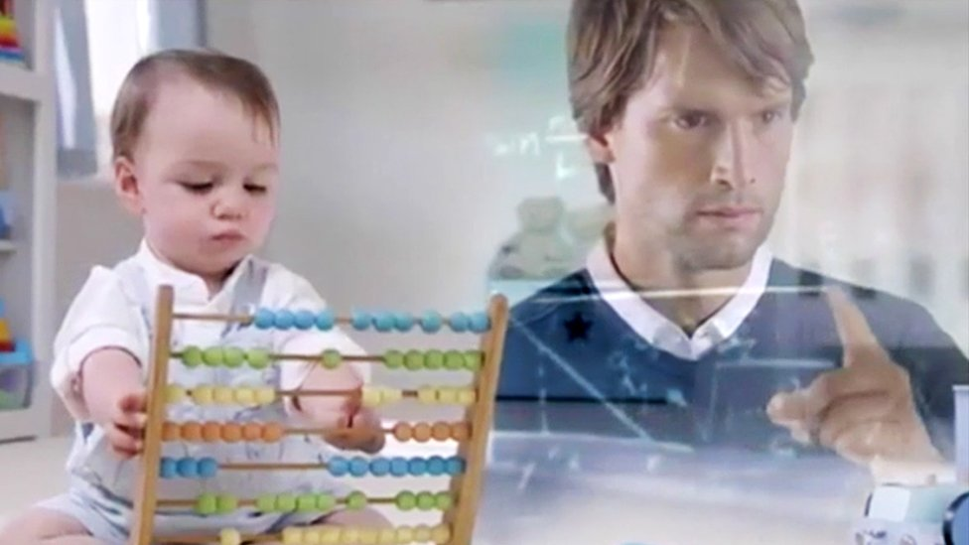

- With suitable examples explain McLuhan’s technological determinism

XxxxxxxxxxxxxxxxxxxxxX

MC8421_A_22

