Register Number:
DATE:
ST. JOSEPH’S COLLEGE (AUTONOMOUS), BANGALORE-27
BA VISUAL COMMUNICATION – II SEMESTER
SEMESTER EXAMINATION: JULY 2022
VC 2415/2417 - History of Visual Arts

Time-2 ½ hrs Max Marks-70

This paper contains one printed page and two parts
I. Write detailed notes on any FOUR in 300 words each. (4X10= 40)
1. Art as a significant form
2. Cave paintings
3. Late Gothic styles
4. Street art
5. Pop art
II. Answer any TWO of the following in 450 words each. (2X15 = 30)
6. Analyse the following painting ‘The feather of truth’ in terms of the characteristics and style of Ancient Egyptian art work.
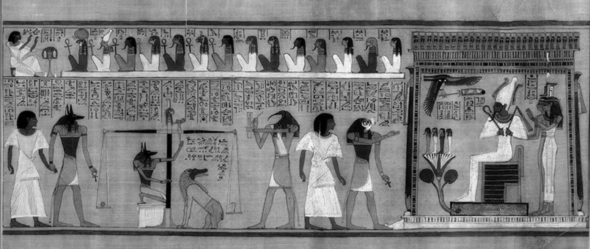
- Write a detailed note on the early renaissance period on the basis of the following points: subject of paintings, painting technique, composition of paintings.
- Explain in detail the Vijayanagar era architecture under the classifications of religious, courtly, and civic architecture.
VC2415/17_22

