Register Number:
DATE:
ST. JOSEPH’S COLLEGE (AUTONOMOUS), BANGALORE-27
BA VISUAL COMMUNICATION - VI SEMESTER
END SEMESTER EXAMINATION: JULY 2022 (Supplementary)
VC 6215: Visual Aesthetics
Time – 2 ½ hrs Max Marks - 70
This paper contains ONE printed page and TWO parts
- Answer any FOUR questions in 250 words each: (4 x 10 = 40)
- What is intertextuality? Explain the different approaches to use intertextuality.
- Write a note on semiotics with the help of any one scholar’s contribution.
- Explain the ethical perspective of visual analysis.
- What is aesthetics? What are the parameters to analyse the aesthetics of an image?
- Write a note on technical perspective and personal perspective of visual analysis.
- What is rasa? What are the different rasas in Indian aesthetics?

- Answer any TWO questions in 500 words each: (2 x 15 = 30)
- Explain in detail the six perspectives of visual analysis.
- What is Feminist Film Theory? Explain.
- Look at the image below. This was captured by Sabatiao Salgado, Brazilian Photojournalist. Keeping in mind the nature of photojournalism as a profession, explain this image.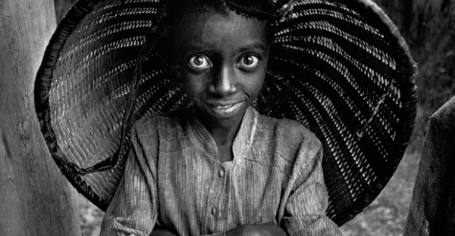

******
VC 6215_A_22

