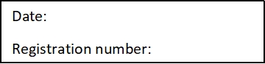

ST. JOSEPH’S COLLEGE (AUTONOMOUS), BENGALURU-27
B.Sc Computer science – IV SEMESTER
SEMESTER EXAMINATION: APRIL 2022
(Examination conducted in JULY 2022)
CS 416 - .Net Technologies
Time- 1½ hrs Max Marks-35

This question paper contains 2 printed pages and two parts

Part A
Answer all of the following (5*2=10)

- Define the role of solution explorer in Visual studio IDE.
- Describe the multiline and passwordchar properties of textbox.
- Give the syntax of nested if with an example.
- Explain the use of “with …. end with” with syntax and example.
- What is the use of finally block?
Part B
Answer any five of the following (5*5=25)

- Design GUI and write a code for the following in VB.Net for textbox
- Change font color
- Change font size
- To transfer the content of textbox to label
- To disable at runtime.
- Add the content of textox to combobox

- Write a short note on usage of message box.

- Write a VB. Net code to design the following output using message box
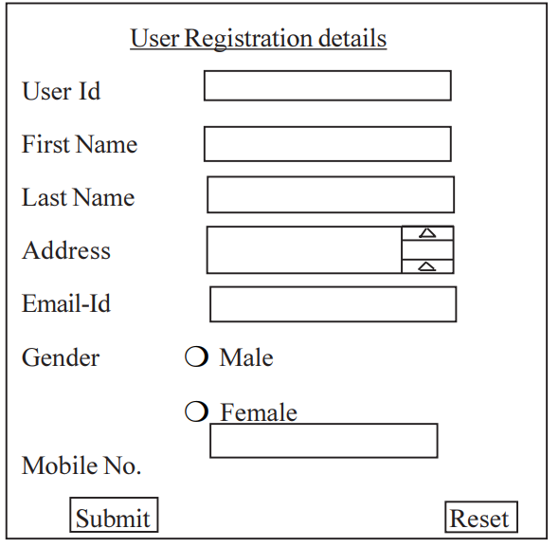

- What is the purpose of radio button and check box explain with suitable example?
- What is the purpose of menu editor? Discuss the procedure for menu creation with the Arithmetic operation example.?
- Explain steps involved to access data from database using ADO .NET.

