Register Number:
DATE:

ST. JOSEPH’S COLLEGE (AUTONOMOUS), BANGALORE-27
BBA– II SEMESTER
SEMESTER EXAMINATION: APRIL 2022
EXAMINATION CONDUCTED IN JULY-AUGUST 2022
BBA 2319: Quantitative Techniques II

Time- 2 ½ hrs Max Marks-70

This paper contains _____ printed pages and four parts

Section A

I. Answer any five of the following (5x2 = 10 Marks)

- What is meant by statistics?
- List any two limitations of statistics.
- If the heights of 5 people are 142 cm, 150 cm, 149 cm, 156 cm, and 153 cm.
Find the mean height.
- The histogram for a frequency distribution is given below.

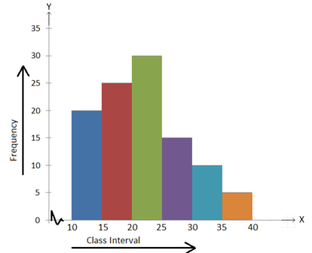

Answer the following.
(i) What is the frequency of the class interval 15 – 20?
(ii) What is the class intervals having the greatest frequency?

- The weights (in kg) of students in a school are shown below.
60, 65, 63, 70, 65, 62, 65, 63, 64, 60, 68, 58, 62, 65, 63, 65, 64, 60, 62, 63.
If the collection of data be grouped into the class intervals 56 - 59, 59 - 62, 62 - 65, 65 - 68, 68 -71 then write the tally marks for the frequency of variate 65 and the class interval 62 - 65.

- Calculate the first quartile from the data: 4, 6, 5, 9, 8, 10, 3

Section B
II. Answer any three of the following (3x5 = 15 Marks)

- Explain the different methods of collecting primary data with examples for each.
- Find the median for the following:
Class interval | Frequency
0-8 | 8
8-16 | 10
16-24 | 16
24-32 | 24
32-40 | 15
40-48 | 7

- The following figures relates to the profits of a commercial concern for 8 years:
Year | 1986 | 1987 | 1988 | 1989 | 1990 | 1991 | 1992 | 1993
Profit | 15,420 | 15,470 | 15,520 | 21,020 | 26,500 | 31,950 | 35,600 | 34,900

Find the trend of profits by the method of three yearly moving averages.

- The scores for nine students in physics and math are as follows:
Physics: 35, 23, 47, 17, 10, 43, 9, 6, 28
Mathematics: 30, 33, 45, 23, 8, 49, 12, 4, 31
Compute the student’s ranks in the two subjects and compute the Spearman rank correlation.

Section C
III. Answer any two of the following (2x15 = 30 Marks)

- Determine the mode of the following distribution using grouping table.
X | 10 | 11 | 12 | 13 | 14 | 15 | 16 | 17 | 18 | 19
F | 8 | 15 | 20 | 100 | 98 | 95 | 90 | 75 | 50 | 30

- Find the variance of the following data.

Observation | 1 | 2 | 3 | 4 | 5 | 6 | 7
Value | 25 | 26 | 38 | 45 | 31 | 30 | 29

- Find the line of regression of y on x for the following data:

x | y
10 | 8
9 | 12
8 | 7
7 | 10
6 | 9
5 | 6

Section D
III. Answer the following (1x15=15 Marks)

- Using the following data, construct Fisher’s Ideal index and show how it satisfies Factor Reversal Test and Time Reversal Test.

Commodity | Price in Rs. Per unit |  | Number of units
 | Base year | Current year | Base year | Current year
A | 6 | 10 | 50 | 56
B | 2 | 2 | 100 | 120
C | 4 | 6 | 60 | 60
D | 10 | 12 | 50 | 24
E | 8 | 12 | 40 | 36

