Register Number:
DATE:

ST. JOSEPH’S COLLEGE (AUTONOMOUS), BANGALORE-27
UG –VI SEMESTER
SEMESTER EXAMINATION: APRIL 2022
(Examination conducted in July-August 2022)
BC IFA 6319: Advanced Financial Management - II
TIME: 2^{1/2} Hour MAX. MARKS: 70 Marks
This paper contains _____ printed pages and four parts
SECTION A
Answer any FIVE of the following questions. Each question carries two marks. (5x2=10)
- Which of the following describes the financial instrument of ‘Ijara’?
  - A joint venture
  - A form of credit sale
  - A lease agreement
  - An Islamic bond
- The current spot exchange rate between USD and INR is 77.4325/$1. The US annual interest rate is 3.75% pa and the Indian annual interest rate is 6.75% pa. What should be the forward rate for USD/INR the end of year-1?
- Examples of political risk does not include;
  - Invasion by powerful neighbours
  - Restricted access to local borrowings.
  - Potentially increased exposure to foreign currency risk.
  - Restricted access to local borrowings.
- Indicate, whether the following statements concerning currency risk are true or false.
  - An interest rate collar is where options are used to set both a maximum and a minimum range for the interest paid or earned.
  - An interest rate floor can be used to hedge an expected increase in interest rates.
- Which of the following statement are correct with regard to business valuation;
  - Market based models are difficult to apply because of the problem of finding similar companies to provide a basis for comparison.
  - The market understands the business properly and estimates the expected returns.
  - A major advantage with the asset valuation model is that it takes account of the true value of intangibles.
  - Valuing start-up businesses presents a different challenge from valuing an existing business
- Match the following and choose the correct option given below;

  - Free trade area
  - Customs Union
  - Multi-lateral agreement
  - Single Market
- ECOWAS
- AFTA
- NAFTA
- MERCOSUR

 | 1 | 2 | 3 | 4
Option-1 | a | b | c | d
Option-2 | d | a | b | c
Option-3 | b | d | c | a
Option-4 | c | a | b | d

SECTION B
Answer any THREE of the following questions. Each question carries five marks. (3x5=15)

- What is trade barrier? Explain various types.
- Briefly enumerate the role of credit rating agencies.
- Tikto Co has an A credit rating. It has $30m of 2 year bonds in issue, which are trading at $90%, and $50m of 10 year bonds which are trading at $108%. The risk free rate is 2.5% and the corporation tax rate is 30%. The following is the credit spread given by S&P on corporate bonds.
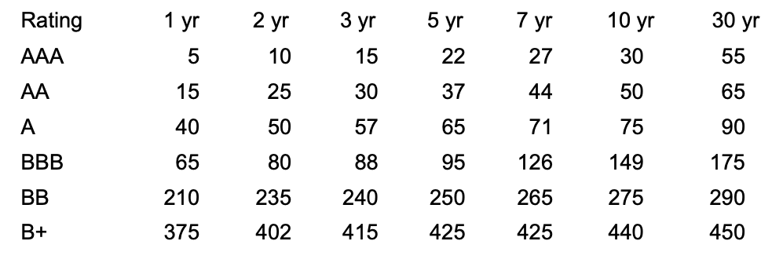

Required to calculate the company's post-tax cost of debt capital.
- Open Co is US based company. It is considering a project in Europe. The project will generate revenue of €250m with associated cost of €70m in Europe at the end of year. The company also pays royalty of $50m to its parent company. Assume tax is paid at 25% in US and 30% in Europe. The forecasted exchange rate for end of year 1 is $1.26/€1. Calculate total tax to be paid in US by the Open Co.
SECTION C
Answer any TWO of the following questions. Each question carries ten marks. (2x15=30)

- Discuss various strategic issues for MNCs in International finance
- Explain various internal and external methods of hedging transaction risk
- Answer the following;
  - Ck Co has just paid a dividend of 25 cents per share. The return on equities in this risk class is 20%. Calculate the value of the shares assuming:
    - no growth in dividends
    - constant growth of 5% pa (5 Marks)
  - JK operates in the advertising industry. The directors are keen to value the company for the purposes of negotiating with a potential purchaser and plan to use the CIV method to value the intangible element. In the past year JK made an operating profit of $137.4 million on an asset base of $307 million. The company WACC is 4.5%. A suitable competitor for benchmarking has been identified as PK. PK made an operating profit of $315 million on assets employed in the business of $1,583 million. Corporation tax is 35%. Calculate the value of JK, including the CIV. (10 Marks)

SECTION D
Answer the following compulsory question. The question carries Fifteen marks. (1x15=15)
- Answer the following:
  - Ela Inc is a US based company. It is considering a 4 year project in India. The project will require an initial investment of Rs 420m and will have a residual value of Rs 120m. The project's pre-tax net inflows in Rs are expected to be:
Year 1 135m
Year 2 280m
Year 3 250m
Year 4 140m
The US parent company will charge the overseas project with $0.05m for management charges each year. The current spot rate is Rs 77.2450 / $1. US inflation is expected to be 4% per annum, and Indian inflation is expected to be 7% per annum. Indian tax rate is 25% and is paid immediately. Any losses are carried forward and netted off the first available profits for tax purposes. Tax allowable depreciation will be granted on a straight line basis, and any residual value will be taxable at 25%. US tax is 30% and is payable 1 year in arrears. Ela Co recently undertook a similar risk project in India and used 10% as a suitable discount rate. You Required: Calculate the NPV and suggest Ela co whether to accept the project or not. (10 marks)
  - Discuss various strategies available for parent company against remittance restrictions by the host country. (5 marks)

************ End of Question Paper *****************

