Register Number:
DATE:
ST. JOSEPH’S COLLEGE (AUTONOMOUS), BANGALORE-27
Open Elective – II SEMESTER
SEMESTER EXAMINATION: APRIL 2022
(Examination conducted in Joly-August 2022)
BC OE 06: Principles of Marketing

Time- 1 ½ hrs Max Marks-60

This paper contains _____ printed pages

I. Answer all of the following (1 x 60 = 60 marks)
- The integration of channels of distribution to ensure that the product is delivered to the customer.
  - Product Mix
  - Promotion Mix
  - Price Mix
  - Place Mix

- Which of the following is NOT a concept of the holistic marketing?
  - Integrated Marketing
  - Performance Marketing
  - Internal Marketing
  - Product Marketing

- Which of the following marketing concepts is based on the philosophy, “A product is not bought but sold”?
  - Product Concept
  - Production Concept
  - Selling Concept
  - None of the above

- The literacy rate of a country will come under which macro environment factor?
  - Demographic Factors
  - Economic Factors
  - Socio-Cultural Factors
  - Legal Factors

- What pricing strategy prices the product at a very low price and then increases the price over time?
  - Loss leader
  - Penetration pricing
  - Predatory pricing
  - Price skimming

- All the activities in selling goods/services to those who buy for resale or business use is called
  - Retailing
  - Wholesaling
  - Supply chain management
  - Marketing

- Which of the statements below are true?
    - The siren logo of Starbucks is an example of a brand
    - The Red Bean Green Tea Frappuccino sold by Starbucks in China is an example of a brand
- Both (i) and (ii)
- Neither (i) nor (ii)
- Only (i)
- Only (ii)

- Gillette has product lines that not only based of gender but also on income and social class. What is the targeting strategy followed by Gillette?
  - Differentiated Marketing
  - Undifferentiating Marketing
  - Personal Marketing
  - Niche Marketing

- ITC Fabelle is marketed as, “a one of it’s kind luxury experience of handcrafted chocolate creations”. This is an example of
  - Segmentation strategy
  - Positioning strategy
  - Targeting strategy
  - None of these

- A promotional video on one’s Facebook feed is an example of
  - Personal selling
  - Advertisement
  - Print ad
  - Product placement

- What pricing strategy offers the product for free but charges for premium features?
  - Loss leader
  - Penetration pricing
  - Freemium
  - Price skimming

- Identify pricing objectives from the following
  - Survival
  - Maximising market share
  - Maximising profit
  - All of the these

- All the activities in selling goods/services to end users/consumers is called
  - Retailing
  - Wholesaling
  - Supply chain management
  - Marketing

- Samples, free trials and payback/cashback are all forms of which promotion tool?
  - Advertising
  - Personal Selling
  - Sales Promotion
  - Public Relations

- Which of the statements below are true?
    - Promotional tools are used to communicate with the customer.
    - Promotion raises awareness, generates sales and creates brand loyalty.
- Both (i) and (ii)
- Neither (i) nor (ii)
- Only (i)
- Only (ii)

- Dividing the market on the bases of age groups is a form of
  - Segmenting
  - Targeting
  - Positioning
  - Placement

- Segmenting consumers according to user and usage related variables is segmentation on the basis of
  - Generation
  - Behaviour
  - Life stage
  - Income

- If a seller does not segment a market then which targeting strategy is more appropriate?
- Differentiated Marketing
- Undifferentiating Marketing
- Both differentiated and undifferentiated marketing
- Niche Marketing

- Starbucks coffee is associated with gourmet coffee. This is an example of
- Segmentation strategy
- Positioning strategy
- Targeting strategy
- None of these

- Which of the following is not a product feature?
- The material used in a Nike shoe
- Nike shoe box
- The Nike logo
- The Nike advertisement

- All activities of designing and producing the container for a product is called
- Branding
- Packaging
- Labelling
- Marketing

- Which of the following are sources of idea generation for new products?
- Employees
- Customers
- Studying competitors
- All of these

- Only this element of the marketing mix produces revenue to a company
- Product
- Price
- Promotion
- Place

- What type of product is associated with a firm that provides legal aid?
- Service
- Durable good
- Non durable good
- Perishable good

- A promotional video played before a YouTube video starts is an example of
- Personal selling
- Advertisement
- Print ad
- Product placement

- Segmenting buyers on the basis of their personality traits is called:
- Psychographic segmentation
- Geographical segmentation
- Demographic segmentation
- Income based segmentation

- A company’s sales have slowed down and profits are declining. At which stage of the Product Life Cycle is the company?
  - Introduction
  - Growth
  - Maturity
  - Decline

- Which of the following is a concept of the holistic marketing?
  - Integrated Marketing
  - Performance Marketing
  - Internal Marketing
  - All of the options are correct

- Which of the following marketing concepts focuses on mass distribution i.e making products widely available?
  - Product Concept
  - Production Concept
  - Selling Concept
  - None of the above

- To which marketing environment do suppliers and marketing intermediaries belong to?
  - Macro environment
  - Micro environment
  - Global environment
  - All of the options are correct

- Clothes and shoes are examples of what type of consumer good?
  - Convenience goods
  - Shopping goods
  - Unsought goods
  - Speciality goods

- Within the market for women’s shoes, shoes for vegan woman, shoes for plus-sized women, shoes for nurses, and shoes for transgendered people would be examples of _____
  - Gap marketing
  - Undifferentiated marketing
  - Mass Marketing
  - Niche Marketing

- Online advertising includes:
  - Selling web cameras
  - Pop-up Ads
  - Bill board advertising
  - Door to door canvassing

- The set of all products and items a particular seller offers for sale
  - Marketing Mix
  - Product Mix
  - Production Mix
  - Product Line

- New product development ends in
  - Commercialisation
  - Test Marketing
  - Business Analysis
  - Concept development

- Rs. 199.99 is an example for _______ pricing.
  - Dual Pricing
  - Low pricing
  - Bundle pricing
  - Psychological pricing

- OR Limited has hired 150 salesmen who will be assigned the task of contacting prospective buyers and creating awareness about the new range of organic incenses introduced by the company. Identify the element of promotion been described in the given lines.
  - Sales Promotion
  - Advertising
  - Personal Selling
  - Public Relations

- Coca Cola has tied up with a TV show so that judges are seen drinking the cola during the show. What is this an example of?
  - Product Placement
  - Guerrilla Marketing
  - Promotion of the TV Show
  - Digital Marketing

- Which of the variables is not used by marketers for demographic segmentation?
  - Age
  - Income
  - Gender
  - Loyalty

- Subway has always been associated with healthy fast food. Which of the following could be a basis for Subway's segmentation strategy?
  - Life cycle
  - Lifestyle
  - Life Stage
  - Life expectancy

- At KFC, a fast-food restaurant, what is being marketed?
  - Goods
  - Service
  - Both goods and service
  - Neither goods nor service

- Satelli Limited has created a very positive reputation about itself and its products in the eyes of general public by participating extensively in various social welfare programs. Identify the component of promotion mixing described in the given lines.
  - Advertising
  - Personal Selling
  - Public Relations
  - Sales Promotion

- Charging customers different prices for essentially the same service is called
  - Differentiated Pricing
  - Supply and demand.
  - Complementary
  - Substitutes

- Premium vehicle brands such as Mercedes Benz maintain very high standards is an example of
  - positioning by price
  - positioning as per quality
  - positioning as per target market
  - positioning as per user

- Consumer behaviour includes
  - How a consumer acquires a product
  - How a consumer disposes of a product
  - How a consumer uses a product
  - All of these

- Which of the following is not a determinant of consumer behaviour
  - Personality
  - Product Quality
  - Family
  - None of these

- The manufactures of X, a mobile phone, have ensured that each software update of the phone will slow the phone down until eventually new updates cannot be supported. This is an example of:
  - Adulterating
  - Planned Obsolescence
  - Misleading warranties
  - None of these

- Pricing a product at less than the cost in order to eliminate competition is called
  - Penetration pricing
  - Predatory pricing
  - Bid rigging
  - Exorbitant pricing

- Relationship marketing refers to
    - Building sustainable relationships with customers
    - A brands ability to create an emotional connect with its customers
- Both (i) and (ii)
- Neither (i) nor (ii)
- Only (i)
- Only (ii)

- The following print ad is an example of_________
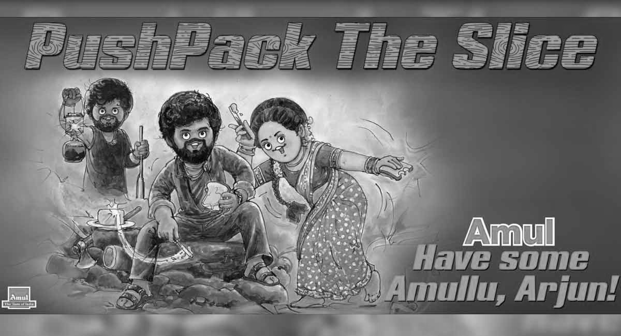
  - Relationship marketing
  - Moment Marketing
  - Guerrilla Marketing
  - All of these

- Marketing is a consumer oriented process
  - True
  - False

- Selling is a broader concept than marketing
  - True
  - False

- Instagram is currently at the Maturity phase of the PLC. A consumer who starts an Instagram account today can be called
  - Innovator
  - Early Adopter
  - Middle Majority
  - Laggard

- Which of the following is an issue of International Marketing?
  - Tariff barriers
  - Political instability
  - Differences in value systems
  - All of these

- The scope of marketing does includes
  - Goods
  - Ideas
  - People
  - All of these

- Deciding how to market to a chosen market segment is called
  - Segmentation
  - Targeting
  - Positioning
  - All of these

- Which of the following is a component of the marketing mix
  - Profit
  - Positioning
  - Place
  - None of these

- Alpha testing refers to
    - Testing within the firm
    - Testing with the customers
- Both (i) and (ii)
- Neither (i) nor (ii)
- Only (i)
- Only (ii)

- The art of translating the value of a product into monetary terms
  - Price
  - Pricing
  - Profit
  - Monetisation

- Identify a con of penetration pricing
  - Slow adoption
  - Creates inefficiencies
  - Difficult to raise prices in the future
  - All of these

