Register Number:
DATE:

ST. JOSEPH’S COLLEGE (AUTONOMOUS), BANGALORE-27
UG –IV SEMESTER
SEMESTER EXAMINATION: APRIL 2022
(Examination conducted in July-August 2022)
BPS 4218: Banking for Business Process Services

Time- 2 ½ hrs Max Marks-70

This paper contains two printed pages and four parts

Section A
I. Answer any five of the following questions (5x2=10marks)

- Who are indigenous bankers?
- What is meant by bank lien?
- List out any two financial services.
- Name the presidency towns established in 1800’s.
- State the stages of money laundering.
- What is nostro and vostro account?

Section B

II. Answer any three of the following questions (3x5=15marks)

- Any contractual relationship between two parties has implicit privileges and rights between banker and customer. Justify.
- Write a note on White labelled ATM’s.
- Outline the importance of principles of sound lending.
- Summarise the concept of Demat services.

Section C

III. Answer any two of the following questions (2x15=30marks)

- Explain the role of buyer and seller in LC.
- Elaborate the importance of bank deposits.
- Banking service channels have paved the way with various options for hassle-free transactions for customers. Discuss any three service channels in detail.

BPS 4218-A-22

Section D
IV. Answer the following question (1x15=15marks)

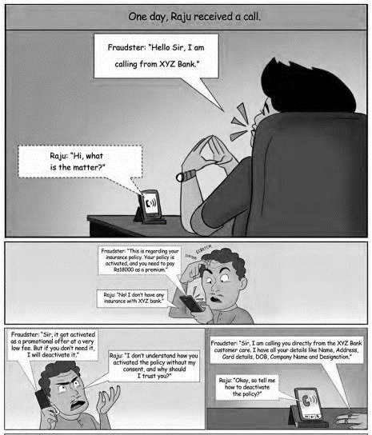
Questions:

- From the above image identify the type of fraud. (2 marks)
- Discuss the type of bank frauds prevalent in the present days. (5 marks)
- What according to you are the various measures to be taken by customer to be aware of such menace? Explain. (8 marks)

*********End of the paper**********

