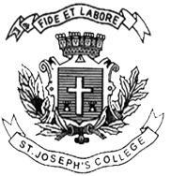
Date:

Register No.:

Register No.

ST. JOSEPH’S COLLEGE (AUTONOMOUS), BENGALURU - 27
II SEMESTER B.A – COMMUNICATIVE ENGLISH
END-SEMESTER EXAMINATION: JULY-AUGUST 2022
CE 221 - Communicative English

Time: 2 hours Max. Marks: 60

Instructions:
1. This paper is for students of II semester Communicative English
2. This paper has TWO printed pages and THREE sections.
3. Please DO NOT exceed the suggested word limit. Also indicate word count after each response.

- Examine the following illustration from Joe Sacco’s Safe Area Gorazde and answer the questions below:

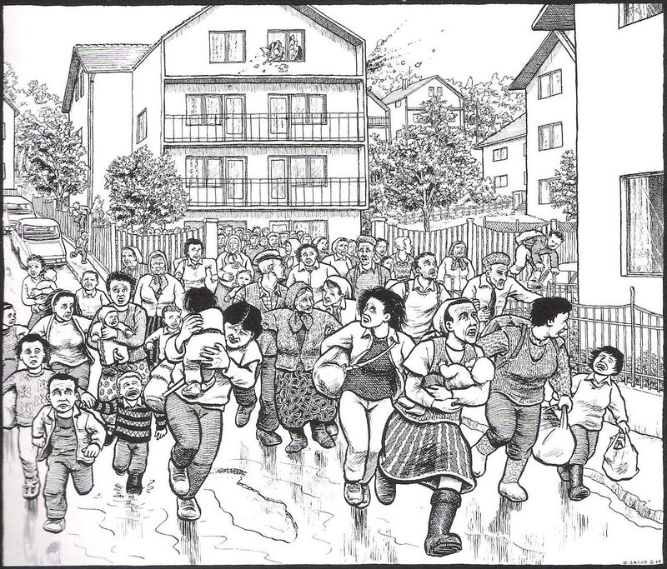

Answer the following questions in not more than FIVE to SIX lines. (3x5=15)

- What is being reported here? Does this illustration achieve anything that photographs or reporting in words don’t?

- Look carefully at the people running and the things they are carrying with them. Now look at the quiet backdrop of houses and trees. What does this contrast achieve?

- Which character or object are you most interested by in this illustration. Why? Explain.

- Answer ANY ONE of the following questions in 150-200 words. (15 marks)

- What is an important quality for a reporter to have if they are interested in covering college campus stories?

- How do design and editing come together? What aspects of these two things do you enjoy the most? Demonstrate with an example from your experience of working on the lab journal this semester.

- Answer each of the following questions in 100-150 words. (3x5=15)

- “haʊ duː jʊ nəʊ aim mæd?” sed ˈælɪs.” This sentence from Alice’s Adventures in Wonderland is written in IPA. How would you write this in the English alphabet?

- Consider this alteration of the sentence, "haʊdjə nəʊ aimmæd?” sed ˈælɪs.” What has changed between these two sentences? What is your explanation for the change?

- Identify the diphthongs in the sentence and give one word as example for each of those diphthongs. You may write the words in IPA or in English

- Respond to the following writing prompt in 150-200 words. (15 marks)

- Avoiding teachers while walking around in college

****

