Register Number:
Date:

ST. JOSEPH’S COLLEGE (AUTONOMOUS), BANGALORE-27
II SEMESTER SUPPLEMENTARY EXAMINATION JULY/AUGUST 2022
GE 218 - General English - BSC/BA/BCA/BVC/BSW/BCOM/BBA

Time: 2 ½ hours Max. marks: 70

INSTRUCTIONS:

1. This paper has 4 printed sides

2. There are TWO parts. Both parts are compulsory

3. You will lose marks for exceeding the word limit.

4. You are allowed to use a dictionary during the examination.

I. Read the two interviews of Sunil Chettri, Ex – Captain of the Indian National Football Team.
‘Sunil Chhetri On His Foreign Stints, Bengaluru FC, And The Rise Of Indian Football’
October 24, 2017 outoftheboot.com

Sunil, a delight to talk to you, I think we should probably start off right at the beginning; when did you first get into football and at what point did you think you could be good enough to be professional?
That’s a tough one to begin with. To be very honest, I cannot put my finger on the moment I realised that I could turn pro. One thing led to another and before I knew it I was playing in the country’s top division and doing decently well!
Your mother and her twin sisters played for the Nepal women’s national team, I believe, so is it fair to say you were pretty much always destined to be a footballer?
I’m not sure if destined is the right word but it did make things a lot easier when I chose to turn professional. My father too played for the Army teams and all conversations around the dinner table were about the game. It became a part of my upbringing and soon, my career. My parents have been my pillars, never once chasing me to focus on books once they saw what the sport meant to me. The signs were more than evident!
And we should point out that over the past 15 years since you turned professional, Indian football has changed quite drastically. How do you feel the game has improved in that time?
In the Indian context, so much has changed. But so much more needs to change. And I’m really grateful that I’ve been around to be part of that change. People are so much more aware about Indian football and maybe it’s the digital space that can take credit for that.
But we are in the middle of a very good time in Indian football – the Under-17 World Cup has come home, the senior team has qualified for the AFC Asian Cup in 2019 and Bengaluru FC are a two-goal win away from a second consecutive AFC Cup final *. Suddenly, it all seems to be happening here!
As captain of the Indian national football team how are you finding that leadership role? Is it nice to give guidance to some of the younger players coming through?
It’s always been an honour to have that armband strapped around but it’s never determined how much more or less I give the team. When I started out I had a fantastic bunch of seniors to look up to who genuinely handed out advice that helped. And it feels good to be able to pass that on.
You’ve got an interesting relationship with Stephen Constantine, there’s definitely an air of excitement surrounding the future for Indian football isn’t there?
There surely is an air of excitement. The Under-17 World Cup is underway and there’s been a fair bit of buzz in the country. The senior team is on track to qualify for the Asian Cup and Bengaluru FC is a two-goal difference away from a second consecutive AFC Cup final. While there is a long way to go, it’s encouraging to see so much going on.
‘Exclusive interview with Sunil Chhetri’
October 07, 2018 . The Week Magazine
What are the best and worst parts of being a captain?
There are no bad parts.
I have been fortunate enough to lead the Bengaluru FC and the national team. It is an unparalleled feeling. An absolute honour.
How do you handle defeat?
I have got used to it now, having understood that winning and losing are both part of the game. It is not possible to win all the time.
And when you lose, you know that all is not lost, and that you will have opportunities to set right what went wrong.

How do you unwind?
Generally, we get a day off in a week, when you go for your massages, pool recovery sessions, and ice baths.
It is important to relax and switch off mentally. I tend to take a lot of rest on my day off. I sleep a lot.
What can we do to promote football in India?
You guys can do a lot. Talk about it. Write about it. Make sure you cover not only the major tournaments, but also the school tournaments. Go and meet the kids who are playing and promote them.
A message to your fans?
Every sportsperson wants to play in a jam-packed stadium. I think fans do not understand how important they are.
Whenever you get a chance, come and watch sports. Let it be football or some other game. Watch it in a stadium. That is the best experience.

I.A. Answer ANY FOUR of the following questions in 5-8 sentences
each:(4x5=20)
- What differences do you notice between the two interviews?
- What do you think Sunil Chettri meant when he said that when you lose, you know that all is not lost and you will have opportunities to set things right?
- Which interviewer has done more research? What impact does this have on the responses? Give examples from the text to support your answer.
- What is the meaning of the word ‘unparalleled’? What feeling does Chettri try to describe with that word?
- What problem with sports coverage does Chettri pinpoint in the second interview?

I.B. Answer the following in about 150 words: (3x10=30)
- “Go and meet the kids who are playing and promote them” says Chettri. In your experience while growing up, were you or someone you know
encouraged by the school or family to pursue sports as a professional choice? Or was focus more on academics? Discuss why that happens.
- Which is your favorite game/sport that you like to play. Tell us how you got interested.
- Has there been a sports person amongst your friends or classmates in school/college whom you looked up to? What caused you to admire him/her?

II. Study the two images show below:
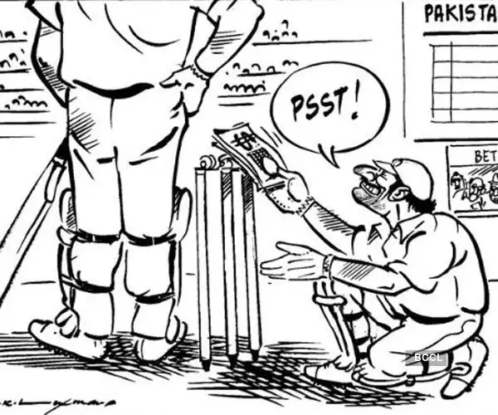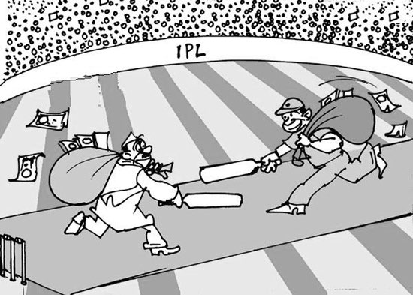

II.A Answer ANY TWO of the following in about 150 words each: (2x10=20)
- While playing games as a young kid, did you or your friends ever cheat? Give one such instance. How did that you make you feel?
- The first image by RK Laxman was drawn several decades before the second one. What does this tell you about the state of cricket in India?
- Have you ever attended a live professional game like IPL? Describe the events and feeling of being surrounded by thousands of fans. If not, while watching games at home do you enjoy it alone or with family and friends? Explain why.

