Register Number:

Date:

ST. JOSEPH’S COLLEGE (AUTONOMOUS), BENGALURU - 27
SEMESTER EXAMINATION: JULY 2022
VI SEMESTER – BA OPTIONAL ENGLISH
OE 6318 - South Asia through Literature, Film and Reportage - II

TIME: 2½ hours MAX. MARKS: 70

INSTRUCTIONS:
- This question paper contains THREE pages and SEVEN questions.
- You may refer to the passages but do not copy from them directly.
- You are allowed to use a dictionary during the examination.

I. Answer any two of the following questions. (2x10= 20 Marks)

- Brian Winston writes, “The fatwa created a new template for anybody affronted by a specific act of free expression to respond with aggression previously unknown.” What is the “new template” of dissent noted by Winston? How does it affect freedom of expression? Explain using at least two examples from texts which you have studied during this semester.
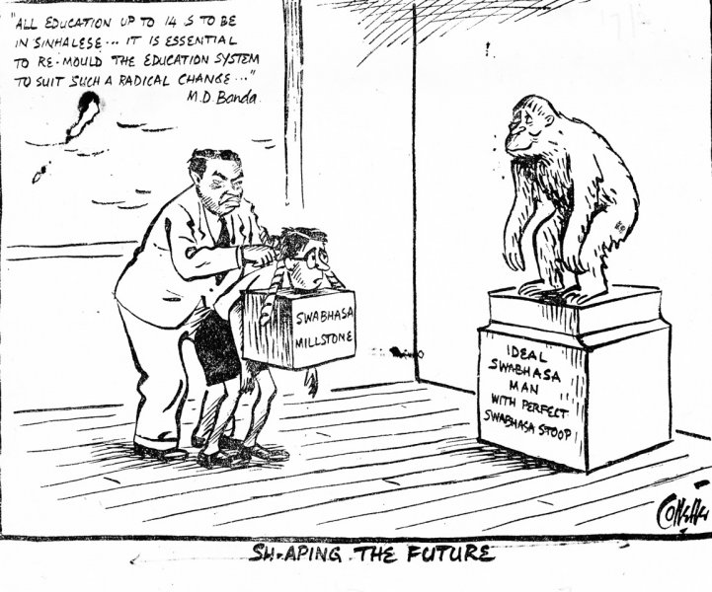
- Closely inspect the following cartoon by the Sri Lankan cartoonist Audrey Collette published in Ceylon Observer in 1950s. Explain the historical background of this cartoon. Do you agree with its message? Give reasons to support your answer.

- “Cultural identities, rather than being fixed, immutable essences, depend upon the versions of narrative and of memories they are based on.” What are the ways in which memory frames the cultural identity of diasporic communities? Explain using examples from texts/film texts studied in class.

II. Read the following excerpt on the Bangladesh Liberation War from Dorothy Deb’s article “Language, Culture and the Creation of Bangladesh” and respond to the questions that follow.

Language and culture do not possess the brute force of arms, hence they cannot determine the outcome of a war independently. Yet, language and culture were the propellants behind the Liberation War: the source of differences, the source of solidarity and the source of constant motivation for the Mukti Bahini. If we look back at the popular slogans of the Liberation War, we find a common thread of loyalty to the Bangla language and the Bengali people. ‘Joy Bangla’, the official slogan of the Liberation War, expresses allegiance to an independent Bangladesh, which subverts the religious nationalism of 1947 to the ethno-linguistic nationalism. It also called for glory to the Bengali identity that had been marginalised and persecuted in Pakistan. ‘Bir Bangali Astro Dhoro, Bangladesh Swadin Koro’ (Brave Bengalis take up arms for the liberation of Bangladesh) was a call to the Bengali people, urging them to pick up arms for the cause of Bangladesh. The slogan was used to signify the responsibility that all Bengali people had towards their language community and was also a push-back against the stereotype that Bengalis are meek and non-martial. A third slogan, ‘Amar Desh, Tomar Desh, Bangladesh, Bangladesh’ (We owe our allegiances to our country Bangladesh), gained popularity amongst Bangla-speaking people across the world. It invoked the sentimental connotations of a ‘desh’ or a country, which represented a sense of belonging. People in West Bengal were particularly drawn to this slogan and felt united with the larger language community in the struggle for an independent Bangladesh.

- How did the question of language lead initially lead to a rupture between East and West Pakistan? Based on the above passage, comment on the role played by language in creating a national identity in Bangladesh. (10 marks)

- Is a uniform language necessary for forging a national identity? How can linguistic debates escalate ethnic and religious conflicts? Explain by comparing the scenario in Bangladesh with those in India or Sri Lanka. (15 marks)

III. Read the following excerpt taken from an article titled “Exile Literature and the Diasporic Indian Writer” written by Amit Shankar Saha and answer the questions that follow.
The modern diasporic Indian writers can be grouped into two distinct classes. One class comprises those who have spent a part of their life in India and have carried the baggage of their native land offshore. The other class comprises those who have been bred since childhood outside India. They have had a view of their country only from the outside as an exotic place of their origin. The writers of the former group have a literal displacement whereas those belonging to the latter group find themselves rootless. Both the groups of writers have produced an enviable corpus of English literature. These writers while depicting migrant characters in their fiction explore the theme of displacement and self-fashioning. The diasporic Indian writers’ depiction of dislocated characters gains immense importance if seen against the geo-political background of the vast Indian subcontinent. That is precisely why such works have a global readership and an enduring appeal. The diasporic Indian writers have generally dealt with characters from their own displaced community but some of them have also taken a liking for Western characters and they have been convincing in dealing with them. Two of Vikram Seth’s novels The Golden Gate and An Equal Music have as their subjects exclusively the lives of Americans and Europeans respectively.
Two of the earliest novels that have successfully depicted diasporic Indian characters are Anita Desai’s Bye-Bye Blackbird and Kamala Markandaya’s The Nowhere Man. These novels depict how racial prejudice against Indians in the UK of the 1960s alienates the characters and aggravate their sense of displacement… The important point to note is that in a cosmopolitan world one cannot literally be a cultural and social outsider in a foreign land. There are advantages of living as a migrant – the privilege of having a double perspective, of being able to experience diverse cultural mores, of getting the leverage provided by the networking within the diasporic community, and more. But it is often these advantages that make diasporic Indians, especially of the second generation, encounter the predicament of dual identities. Such ambivalence produces existential angst in their psychology. The world simply refuses to become less complex.

- What does the writer mean by “the predicament of dual identities”? How does this emerge as a central theme in diasporic literature? (10 marks)

- The writer recurrently uses the terms “displacement” and “dislocation”. How does this process of displacement and alienation shape characters in diasporic fiction? Provide examples from various texts or films to substantiate your views. (15 marks)

