Date:
Registration number:

ST. JOSEPH’S COLLEGE (AUTONOMOUS), BENGALURU-27
B.SC. ELECTRONICS – II SEMESTER
SEMESTER EXAMINATION: APRIL 2022
(Examination conducted in July 2022)
EL 218 – Amplifiers and Oscillators

Time- 2 ½ hrs Max Marks:70
This question paper contains THREE printed pages and THREE parts

PART-A

Answer any five questions. 5x8=40 Marks

1.a) With the help of circuits explain the working of a Class B push pull amplifier and derive its
efficiency.
b) Define harmonic distortion in amplifiers and mention how it is improved in Class B
amplifier. (6+2)

2.a) Discuss the need for tuned amplifiers and draw the circuit for a double tuned amplifier.
Mention the coupling schemes for maximum output in these amplifiers.
b) What is the Barkhausen criterion for oscillation to occur in a circuit? Write the circuit for
a phase shift oscillator and write the value for minimum gain needed to start the
oscillations. (4+4)

3.a) With help of a circuit explain the working of a Hartley oscillator and give the expression
for its output frequency.
b) Sketch the monostable multivibrator using transistor and explain its transition from ON
to OFF state. Write the expression for its pulse width. (4+4)

4.a) Write the internal block diagram of IC 555 and describe each section.
b) Define the terms Input offset voltage, CMRR, Slew rate and SVRR (4+4)

5.a) Derive the voltage gain of a dual input balanced output differential amplifier.
b) What are the disadvantages of open loop differential amplifier? (6+2)

6.a) Draw the current mirror circuit and explain.
b) Derive the expression for a voltage shunt feedback amplifier. (4+4)

7.a) Write an op amp integrator circuit and derive its output.
b) Explain the working of an op amp first order low pass filter and sketch its frequency
response. (4+4)

PART-B
Answer any five questions. 5X4=20
8. Determine the output for the given circuit if Vin=10µV.

9. A class A power amplifier has a transformer as the load. If the transformer has a turns ratio of 10 and the secondary load is 100 Ω, find the maximum a.c. power output. Given that zero signal collector current is 100 mA.

10. The ac equivalent circuit of a crystal has these values: L = 1H, C = 0.01 pF, R = 1000 Ω and Cm = 20 pF. Calculate fs and fp of the crystal.

11.Determine the minimum and maximum frequency for the given circuit.
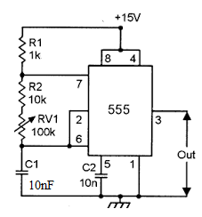
12. Determine Vo for the given circuit.
13. Design a high pass filter for a cut-off frequency of 5KΩ and passband gain of 6.
14. An op amp having the following values is connected as shown. A=200,000, R_{i}=2MΩ,
R_{o}= 75Ω, and f_{o}=5Hz.
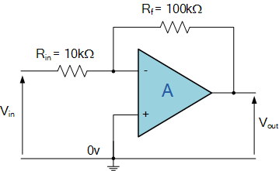
Determine A_{f}, R_{if}, R_{of} and f_{of}.

PART-C
Answer any five questions. 5X2=10
15. Class C amplifiers are tuned amplifiers, justify.
16. Identify the circuit and mention its current gain.
17. What is the need for 3-RC sections in a phase shift oscillator circuit?
18. Bistable multivibrator is also known as one bit memory device-substantiate.
19. Determine the output for the given circuit. ( Resistances as indicated are in Ω )
20. An operational amplifier has ___________________ as the first building block. Why?
21. Mention the characteristics of a second order low pass filter.

********************************************************

