Date:
Registration number:

ST. JOSEPH’S COLLEGE (AUTONOMOUS), BENGALURU-27
B.Sc. ELECTRONICS - II SEMESTER
SEMESTER EXAMINATION: APRIL 2022
(Examination conducted in July 2022)
EL 221 – Amplifiers, Oscillators and Op-amp

Time- 2 hrs Max Marks-60

This question paper contains THREE printed pages and THREE parts

Part A
Answer all 10 questions 10x1 = 10

- In a multistage amplifier, the voltage gains of first, second and third stages are 5 dB, 4 dB and 2 dB respectively. What is the over all voltage gain?
- 11 dB b) 40 dB c) 22 dB d) 13 dB
- A power amplifier
- converts input ac signal into ac output power
- coverts input ac signal into dc output power
- converts DC power supply into ac output power
- amplifies ac signal
- In a tuned amplifier, collector impedance
- Does not change at resonant frequency b) is minimum at resonance
c) maximum at resonance d) depends on the transistor
- Identify the correct statement from the following.
- An enhancement MOSFET conducts even when V_{GS} is zero.
- A depletion type MOSFET does not conduct when V_{GS} is zero
- An enhancement type MOSFET has two modes of operation
- An enhancement type MOSFET conducts only if gate voltage is applied.
- Which oscillator gives audio frequency output?
- Colpitt’s oscillator b) Hartley oscillator
c) phase shift oscillator d) Crystal oscillator
- In a 555 timer IC, V_{CC} = 9 V. Then voltage at
a) pin 2 is 3 V b) pin 6 is 6 V c) pin 7 is 9 V d) pin 5 is 6V
- In a closed loop inverting op-amp, input voltage is 2 V and output voltage is -6 V. The voltage at pin no.2 is
a) 2 V b) 4 V c) 6 V d) 0 V
- UGB of an op-amp is 1 MHz. What is the differential gain of the amplifier at 1 MHz?
- Infinity b) 0 dB c) 1 dB d) approximately 200000
- A comparator is constructed using an op-amp in
- Open loop configuration b) Inverting closed loop configuration
c) non inverting closed loop configuration d) any of these configurations

- Which of the following circuits can store a binary digit?
- Astable multivibrator b) Monostable multivibrator
c) Bistable multivibrator d) Schmitt trigger

Part B
Answer any five of the following: 5 x 6 = 30

- a) Draw circuit of a Class B push pull amplifier and mention its circuit efficiency.
b) Draw the circuit of tuned amplifier and frequency response of a tuned amplifier. (3 +3)

- a) Draw an N-channel JFET with proper biasing. Draw the nature of drain characteristics and transfer characteristics
- Draw the circuit of a CMOS inverter (4 + 2)

- a) Draw block diagram of voltage series feedback amplifier and mention the effect of feedback on input and output resistance.
b) Explain how phase shift oscillator satisfies Barkhausen criteria for sustained oscillations. (3 + 3)

- a) Draw internal block diagram of IC555.
b) Draw voltage-controlled oscillator using IC 555. (3 + 3)

- a) Draw the circuit of LM317 as a variable voltage regulator and write expression for its output voltage.
b) Define the op-amp parameters, CMRR, slew rate and input offset voltage. (3 + 3)

- a) Determine the polarity of the output voltages of the following op-amp.
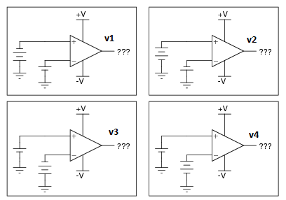

V1 = v2 = v3 = v4 =

b) Draw non-inverting op-amp and derive expression for voltage gain. (2 + 4)

17.a) Draw op-amp subtractor and obtain expression for output.
b) Draw op-amp differentiator and obtain expression for its output. (3 +3)

Part C

Answer any five of the following: 5 x 4 = 20

18. A Darlington amplifier has input and output transistors of current gain 150 and 100 respectively. If the base current to the input transistor is 2 µA, calculate the emitter current of the second transistor.

19. A class B amplifier has an efficiency of 65 %. If the maximum collector dissipation of each transistor is 3 W. Calculate the dc input power and ac output power.

20. In a JFET I_{DSS} = 15 mA and V_{GS(OFF)} = -5 V. Calculate the drain current for V_{GS} = -4 V.

21. Calculate the oscillation frequency of a Wein-bridge oscillator if the bridge consists of resistors R1 = R2 = 120 Ω and capacitors C1 = C2 = 1600 pF.

22. A monostable multivibrator using IC555 is used to produce pulses of width 10 µS. Calculate the value of resistance if the capacitor used is 1000 pF.

23. Calculate the output voltage of the circuit below.

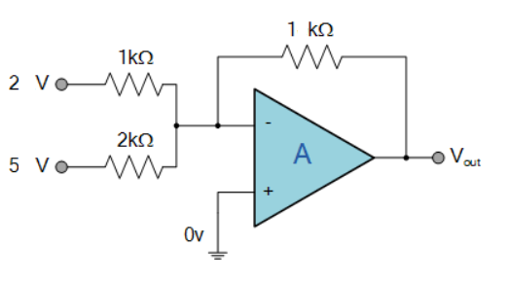
24. Design an active low pass filter of cut-off frequency 10 kHz and maximum voltage gain of 5.

xxxxxxxxxxxxxxxxxxxxxxxxxx

