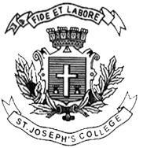
ST. JOSEPH’S COLLEGE (AUTONOMOUS), BENGALURU -27
Registration Number:
Date & session:
B.VOC. VISUAL MEDIA AND FILMMAKING – I SEMESTER
SEMESTER EXAMINATION: OCTOBER 2022
(Examination conducted in December 2022)
VOF 1121: SHORT STORIES

Time: 2 Hours Max Marks: 60

This paper contains ONE printed pages and ONE part

PART- A

Answer any SIX of the following in 300 words each. Discuss the narrative structure and the cultural backdrop of the story in detail. 6x10=60
- Patol Babu, Film star- Satyajit Ray
- My aunt Gold teeth- V S Naipaul
- In the South- Salman Rushdie
- Khol Do- Saddat Hassan Manto
- The woman on platform 8- Ruskin Bond
- Out of business- R K Narayan
- Lottery- Munshi Premchand
- The Umbrella Man- Roald Dahl

