Register No:
Date:7-12-2022(9AM)

ST. JOSEPH’S COLLEGE (AUTONOMOUS), BANGALORE-27
M.Com - III SEMESTER
SEMESTER EXAMINATION: OCTOBER 2022
(Examination conducted in December 2022)
MCODEF 9318 / 9320 - Security Analysis and Portfolio Management

This paper has two printed pages and four parts

Time- 2 ½ hrs Max Marks-70
Section A
I. Answer any TEN of the following questions. Each question carries two marks. (10x2 marks = 20)

- Give the meaning of Diversification.
- State two examples of systematic risk.
- What is portfolio revision?
- State the Dow Theory.
- Is investment the same as gambling? Justify your answer.
- Draw a bullish Bar chart.
- What is an arbitrage pricing theory?
- List any two assumptions of CAPM
- What is odd lot theory?
- Differentiate between CML and SML.
- What is passive revision strategy?
- What is Advance -Decline theory in security analysis?

Section B
II. Answer any THREE of the following questions. Each question carries five marks. (3x5 marks = 15)

13. Write a note on Markowitz's Model of portfolio selection.

14. Identify and explain the following chart patterns:
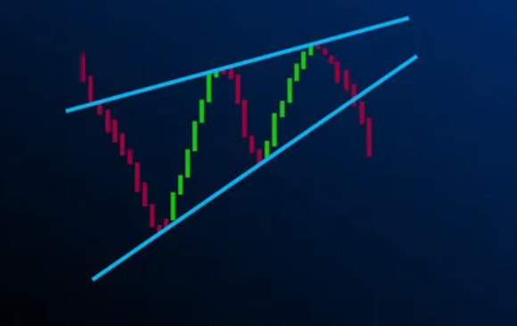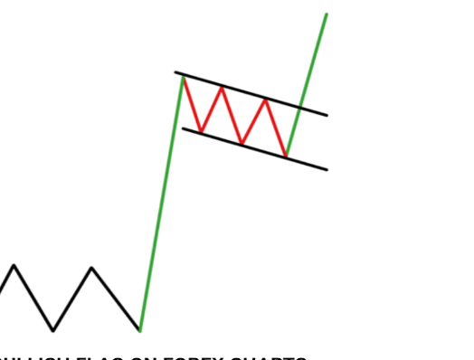

15. Mr. Ram has invested Rs. 100000 in Star Foods. Given below are the probable returns for the same. Compute the return and risk of this stock.
State of the economy | Probability of Occurrence | Star Foods Return (%)
Boom | 0.3 | 16
Normal | 0.5 | 11
Recession | 0.2 | 6

16. Mr. Prem provides the following information about stock A, B and C.
Stock | Alpha | Beta
A | 0.07 | 1.52
B | 0.09 | 0.81
C | -0.02 | 1.14

If the market index is expected to have a return of 20% which single stock would Mr.Prem prefer to own from the return point of view as per single index model.

17. Identify whether the following securities are overpriced, underpriced or fairly priced according to CAPM.
Securities | Estimated Returns | Beta | Rm | Rf
A | 15 | 1.2 | 16 | 4
B | 12 | 1.5 | 16 | 4
C | 11 | 2 | 16 | 4
D | 8 | 0.8 | 16 | 4
E | 9 | 1.4 | 16 | 4

Section C
III. Answer any TWO questions. Each question carries ten marks. (2x10 marks =20)

18. Highlight and discuss the various investment avenues.
19. Mr. Raj is a potential client for your company. As a wealth manager you are asked to throw light on appraisal of intrinsic value done through the EIC framework.
20. Following information is available regarding six portfolio’s:
Portfolio | Return | Standard deviation | Beta
A | 22 | 21.2 | 0.7
B | 18.6 | 26 | 0.8
C | 14.8 | 18 | 0.62
D | 15.1 | 8 | 0.95
E | 26.5 | 19.3 | 0.65
F | -9 | 4 | 0.42
Rf | 9
You are required to rank these portfolios using Sharpe’s method and Treynor’s method

Section D
IV. Answer the following compulsory question. The question carries fifteen marks. (1x15 marks=15)
21. The returns on security STAR and the market portfolio for a 10 year period are given below:
Year | Return on Security STAR (%) | Return on market portfolio (%)
1 | 15 | 9
2 | 16 | 12
3 | 10 | 6
4 | -15 | 4
5 | -5 | 16
6 | 14 | 11
7 | 10 | 10
8 | 15 | 12
9 | 12 | 9
10 | -4 | 8
a) What does beta of a stock indicate?
b) Calculate the β of STAR.
c) Compute the alpha of STAR.

*****************

