Register Number:
DATE:
ST. JOSEPH’S COLLEGE (AUTONOMOUS), BANGALORE-27
MA JOURNALISM & MASS COMMUNICATION - III SEMESTER
SEMESTER EXAMINATION: OCTOBER 2022
(Examination conducted in December 2022)
MC 9422: DATA JOURNALISM (THEORY)

Time - 2 ½ hrs Max Marks - 70

This question paper has THREE printed pages and FOUR parts
(Write the answers clearly, precisely, and to the point. Keep strictly to the principles of journalistic writing.)
- Write short notes on any FIVE in 100 words each. (5X5=25)
- Plain Facts
- Data Point
- Simon Rogers
- Cultural authority in Data Journalism
- Data scrutiny
- Out-of-box solutions versus in-house
- Philip Meyer

- Answer any TWO of the following in 300 words each. (2X10=20)

- The data infrastructure ecosystem militates against objectivity in data journalism. Analyse the statement.
- Offer a story idea to produce a four-chart/graph visualisation for a reputed data column. The story should contain a minimum of four different angles.
- With the usage of computation technology and databases, the USA ushered into a golden era of investigative journalism in the second half of the 20th century. Explain with examples.

- Answer any ONE of the following. (1x10=10)

- Write a 100-word news story based on the following two visualisations that appeared in The Mint.

MC 9422_A_22
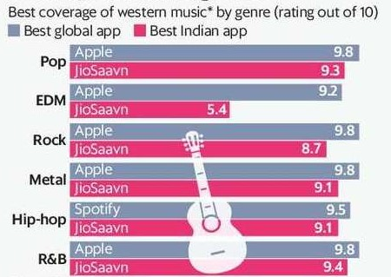

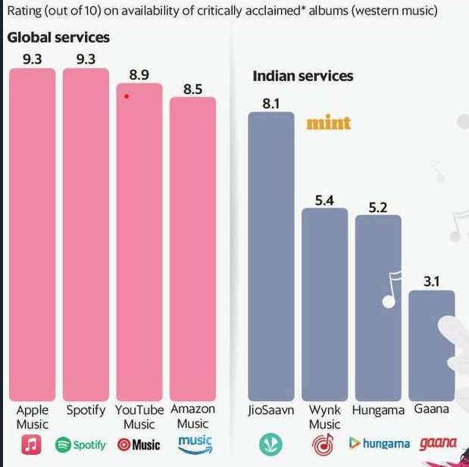

- Write a 100-word story analysing the following visualisations. The visualisations show the performance of nominated Rajya Sabha MPs on four parameters.

MC 9422_A_22
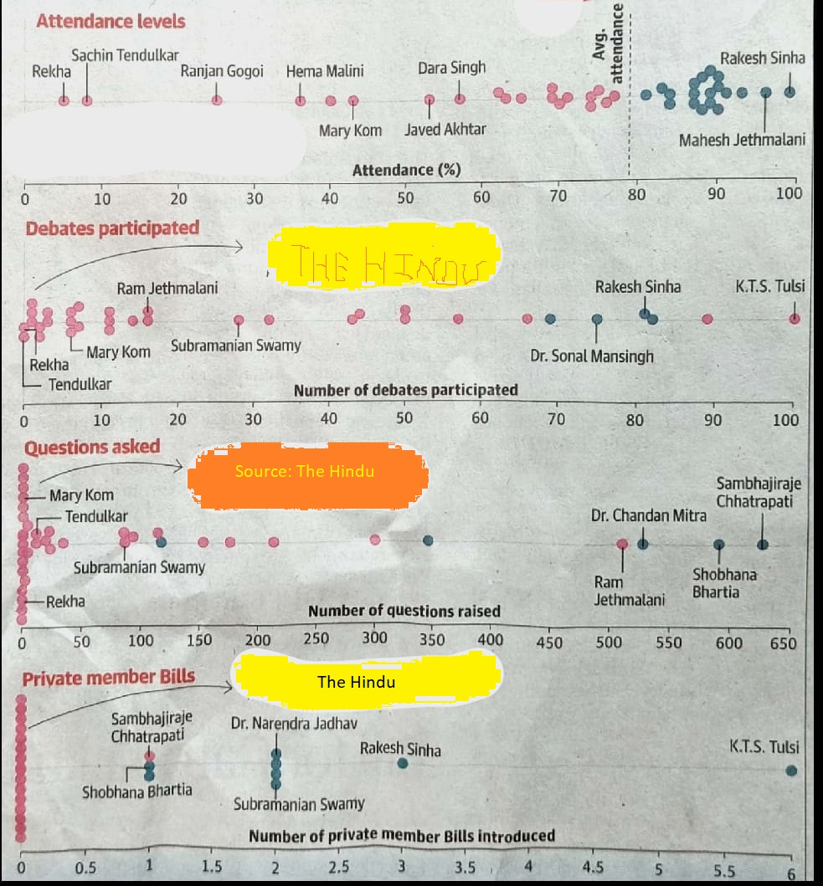

- Answer any ONE of the following in 500 words. (1X15=15)

- Evaluate the challenges in producing data-driven news based on NCRB as a source.

- Explain the process of producing data news stories from- finding the data, scraping, transposing, cleaning, using suitable algorithms, and creating visualisations.

MC 9422_A_22

