ST. JOSEPH’S COLLEGE (AUTONOMOUS), BENGALURU -27
Registration Number:
Date & Session: 14-12-2022 (9am)
B.Com – V SEMESTER
SEMESTER EXAMINATION: OCTOBER 2022
(Examination conducted in December 2022)
BCDEM5618: Retail Management
Time: 2 ½ Hours Max Marks: 70
This paper contains __2____ printed pages and __4___ parts

Section A
I. Answer any five of the following (5 X 2 = 10marks)

- What is E-tailing?
- Why is Space planning?
- What is Retail Law?
- What is multi-channel retailing?
- State the Stages of Consumer Buying Process.
- What is Retail EDI?

Section B
II. Answer any three of the following (3 x 5 = 15 marks)
- What is the importance of Retail Management?
- What are the ethical issues in Retailing?
- Write a note on Electronic Self label and Electronic Article Surveillance.
- Explain the Theory of Natural Selection in Retail.

Section C
III. Answer any two of the following (2 x 15 = 30 marks)
- Explain the types of Retail Store and Non-store Formats
- Write short notes on the following:
a) Category Management (5 marks)
b) Retail Life Cycle Theory (5 marks)
c) Social Factors affecting Retailing (5 marks)
- a) Explain what is the BGC matrix with a relevant Retail Example. (7 marks)
b) Explain the types of Store Layouts in Retail. (8 marks)

Section D

IV Answer the following (1 X 15 = 15 marks)
- Abu Dhabi-based Lulu Group International has opened its new shopping mall in Bengaluru, after the pandemic somewhat delayed its mall development pipeline in India. Global Malls, an eight lakh sq ft property in Rajajinagar, opened on Monday and is spread across 14 acres. In Bengaluru, for instance, the focus is on the Lulu hypermarket, and we have mastered the ‘hypermarket’ model over a period of time.
the design and layout of Global Malls and our other upcoming malls have been planned in accordance with covid safety protocols. We have wide alleys, corridors, and shopping aisles, to aid social distancing, and promote the health and safety of shoppers. customers can shop for their regular grocery products online at Lulu Hypermarket, while for their bigger shopping needs such as food and beverages, apparel, and lifestyle products.

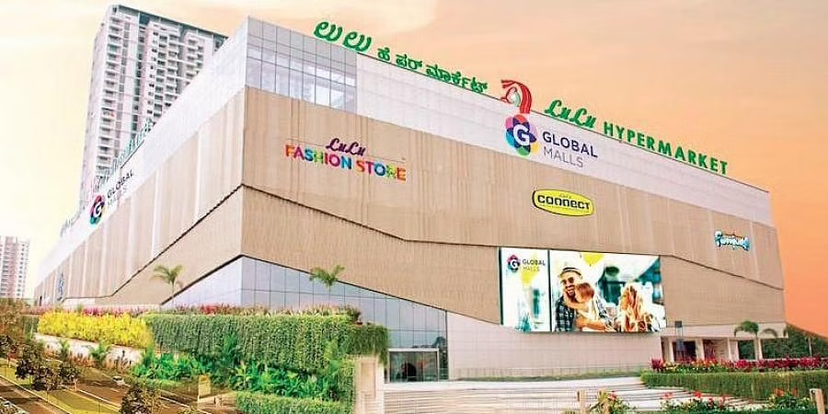

- Explain the growth of the Indian Retail Industry (5 marks)
- Elaborate the Internal and External Atmospherics of LULU mall (10 marks)

