Register Number:
Date:
ST. JOSEPH’S UNIVERSITY, BANGALORE - 27
I B.A – COMMUNICATIVE ENGLISH
END-SEMESTER EXAM: DECEMBER 2022
COMMUNICATIVE ENGLISH: CE 121

Time- 2 hrs Max Marks- 50

Instructions:
- This paper is for students of I semester Communicative English.
- The paper has FOUR SECTIONS and TWO printed pages.
- You will lose marks for exceeding the word limit.
- You are allowed to use a dictionary.

- Examine the illustration from Satrapi’s Chicken with Plums and answer the questions below:
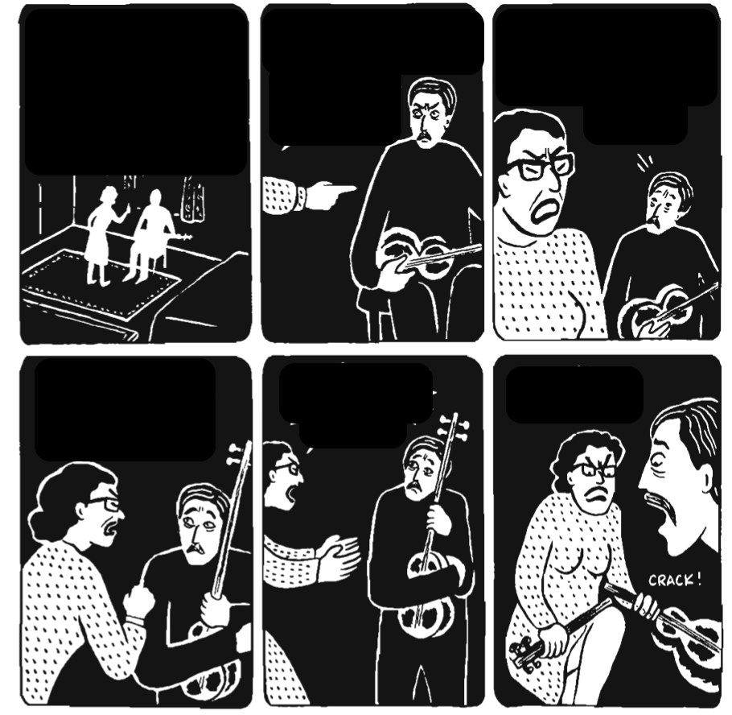

I.A. Answer the following questions in 5-6 lines: (3 x 5 = 15)
- Look at the position of the tar in relation to Nasser Ali. Why does the position change from panel to panel?
- Why are the characters shown wearing clothing of opposite colours?
- Whose face changes the most in the drawings? Why do you think this is so?

II. Answer ANY ONE of the following questions in 100-150 words: (10 Marks)
- Using the following sentences, explain the concept of Deep structure and Surface structure:
Mona ate the candy.
The candy was eaten by Mona.
- According to Charles Darwin’s vision of how language might have originated, early humans had developed musical ability even before they did language. How do you imagine human beings developing the ability of language from music? Could there be other factors influencing the development of language?

III. Read the news article from Deccan Herald below and answer the following question: (10 Marks)

In a big relief to passengers travelling in auto rickshaws aggregated by Ola, Uber and Rapido, the Karnataka Transport Department on Friday issued an order doing away with the surcharge and limited the platform fee (commission) collected by the companies to 5 percent.

As per the order, applicable to all the companies that aggregate auto rickshaws, passengers cannot be charged more than the fare fixed by the government except for the commission allowed by the department and the goods and service tax.

"As per the directions of the court, we held meetings with both the companies and the passengers. We took into consideration all the views placed before us before deciding on the platform fee of 5 per cent," Transport Commissioner S N Siddaramappa said.

As per the revised fares notified in November 2021, passengers will pay Rs 30 base (up to the first 1.9 km) and Rs 16 per every subsequent kilometre. However, the aggregators had charged over 300 per cent more, which led to the department banning them from providing auto rickshaw services.

- Write an appropriate headline and concluding paragraph for the article above.

IV. Respond to the following writing prompt in 100-150 words. Map out the prewriting process in 5 lines as part of the task. (5+10 Marks)
- Outside

****

