Registration Number:
Date & Session 5-12-2022 ( 9am)
ST. JOSEPH’S COLLEGE (AUTONOMOUS), BENGALURU -27
B.Sc – V SEMESTER
SEMESTER EXAMINATION: OCTOBER 2022
(Examination conducted in December 2022)
ECS 5118: BASIC ECONOMETRICS

Time: 2 ½ Hours Max Marks: 70
This paper contains ___3___ printed pages and ___3__ parts

PART A: Answer any TEN of the following questions 10x3=30

- The Gauss-Markov theorem states that the OLS estimator is BLUE. In a sentence, state explain what U is and what it implies?

- What is the difference between an estimator and an estimate? Explain in the context of simple regression model given underlying population regression line $β_{0}+ β_{1}X_{i}$

- For a regression model, the Explanatory Sum of Squares is 0.27 while the Residual Sum of Squares is 1.67. Calculate the $R^{2}$.

- Consider the following regression line: $\hat{BP}$= 698.9 – 2.28 *EX where BP is the Blood-pressure and EX is minutes of daily Exercise. If the standard error of the slope coefficient is 0.52. What is the t-statistic of the slope coefficient?

- Re-formulate the following equation to be linear in parameters: $y=Ax^{β}e^{u}$ and interpret the slope coefficient.

- A researcher seeks to understand Sales as a function of advertisement spending and dummy variables for 4 exhaustive regions (North, South, East and West), what specification would imply a dummy variable trap? What is the solution?

- One way to interpret the coefficient of explanatory variable in the case of multiple linear regression model is the “partialing-out” interpretation. Explain.

- Even if a variable is irrelevant, including it in OLS regression still increase the $R^{2}$ . Why?

- What is the interpretation of $β_{1}$ for this model: ${lnY}_{i}= β_{0}+ β_{1 }X_{i}+u_{i}$ ? How does the interpretation of $β_{1}$change if the model is: ${lnY}_{i}= β_{0}+ β_{1 }X_{i}+{β_{2}Z_{i}+u}_{i}$ ?

- Assume that the true model includes variables $X_{2} and X_{3}$ along with the constant term. What is the impact of excluding $X_{3}$ which is a relevant variable on the coefficient of $X_{2}$ ?

- What is the difference between t-test and F-test?

- Give an example of AR(1) and AR(2) error structure.

PART B: Answer any TWO of the following questions 2x5=10

- What is multicollinearity? What are the problems associated with multicollinearity (i) when it is exact and (ii) not perfect? Describe potential solutions.

- A researcher is interested in understanding how wages are affected by being part of a union. In addition, she is interested in finding if being a union member affects wages differently for male and female. Can an interaction model be used for this analysis? Explain.

- Describe the Chow test which can be used in case you are considering splitting your data in 2 subsamples and estimating 2 models or not differentiating the subsamples. Recall that it is a variant of F test with the general form of
F = $\frac{Improvement in\frac{fit}{extra}degrees of freedom}{ \frac{residual sum of squares}{degrees of freedom remaning}}$

PART C: Answer any TWO of the following questions 2x15=30

- What is heteroscedasticity? Discuss consequences. If heteroscedasticity has a specific form $σ^{2}=λZ_{i}$where Z is a known variable, how should we proceed?

- Consider the following models (X is a continuous variable and D a dummy variable):
  - $Y= β_{0}+ β_{1}X+β_{2}D+u$
  - $Y= β_{0}+ β_{1}X+β_{2}\left(X*D\right)+u$ .When would we use model a, and when would we use model b?

- The result of estimating the impact of ASVABC (cognitive ability), years of schooling for mother (SM) and father (SF) on Years of Schooling of respondent (S) is shown below.

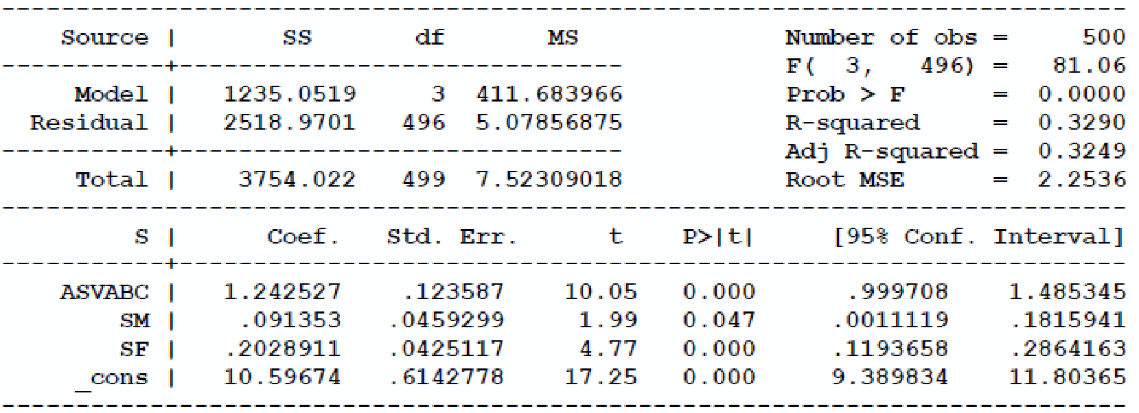
  - Interpret all the coefficients.
  - What does the F-statistic of 81.06 relate to and how would you go about testing for the joint significance of father’s and mother’s schooling?
  - Given the coefficient of SF (0.091) and standard error (0.045), how is the 95% confidence interval generated?

