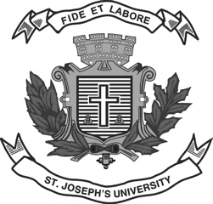
Register Number:
Date: 13-12-2022

ST. JOSEPH’S UNIVERSITY, BANGALORE – 27
END-SEMESTER EXAMINATION: DECEMBER 2022
I SEMESTER - REGULAR
ENDE 7518: MA LINGUISTICS

Time- 2 hrs Max Marks- 50

Instructions:
- This paper is for students of I semester MA LINGUISTICS (all shifts).
- The paper has FOUR SECTIONS and TWO printed pages.
- You will lose marks for exceeding the word limit.
- No dictionary allowed.

I. Answer the following in FIVE to SIX lines. (3x5=15)
1. Could words like miaow and dhaddam be considered likely sources of human speech sounds?
2. What is the paradigm in paradigmatic?
3. Is displacement a negative thing?

II. Answer the following questions. (15 Marks)

Look at the words in Sets A, B, and C.
Set A: encircle, engulf, enforce, encourage, entangle
Set B: embody, embalm, embrace, empower, empanel
Set C: smoothen, tighten, sharpen, stiffen

4.a. Do you consider en to be an affix in Set A? What is its function?
4.b. Are the words enhance and envelope formed by the same derivational process?
4.c. Is the affix in the words in Set B similar in function as the one in Set A?
4.d. Is the affix en in Set C similar to the affix in Set A or Set B?
4.e. How many in Set A take an opposite?

III. Answer the following. (2x5=10)

5. Identify the fricatives in the phrase below. Mark the voice, place and manner of articulation.

Very doozy

6. Attempt a morphological analysis of the words
- Transitioning
- Unbelievable

IV. Answer the following in 150-200 words. (10 Marks)
7. What is your mother tongue? Which language family does it belong to? Draw out some of the key characteristics of this language family.

