ST. JOSEPH’S COLLEGE (AUTONOMOUS), BENGALURU - 27
Reg. No.:

Date:
END SEMESTER EXAMINATION: DECEMBER 2022
MA ENGLISH – SEMESTER III
EN 9318 - ENGLISH STUDIES 3: LITERARY THEORY

TIME: 2½ hours MAX. MARKS: 70

INSTRUCTIONS:
- This question paper contains THREE PAGES, THREE SECTIONS and NINE QUESTIONS.
- You may refer to the passages given but do not copy from them directly.

I. Read the following excerpt taken from G Thomas Tanselle’s “The Editorial Problem of Final Authorial Intention” and answer ALL THREE of the questions in around 75-100 words each. (3x5=15 Marks)

Scholarly editors may disagree about many things, but they are in general agreement that their goal is to discover what an author wrote and to determine what form of his work he wished the public to have. There may be some difference of opinion about the best way of achieving that goal; but if the edition is to be a work of scholarship – a historical reconstruction – the goal itself must involve the author's "intention." The centrality of that concept to scholarly editing can be illustrated by W. W. Greg's "The Rationale of Copy-Text' which, in the quarter century since it first appeared, has established itself as the most influential document in modern editorial theory. What Greg succeeded in accomplishing was to provide a rationale for selecting, and then emending, a basic text in those cases in which the choice was not made obvious by the historical, biographical, bibliographical, and linguistic evidence available. In such instances, an editor requires some guiding principles by means of which he can maximize the chances of adopting what the author wrote and minimize the chances of incorporating unauthorized readings into his text.

- The excerpt given focuses on the importance of locating authorial meaning in the process of editing a text. Do you think the same applies while reading a text? Give reasons in support of your answer.

- Wimsatt & Beardsley as well as Roland Barthes challenge the centrality of authorial intention in literary criticism. But how are their approaches based on fundamentally different premises?

- Tanselle discusses the need to “minimize the chances of incorporating unauthorized readings into his text.” What does this suggest about the author’s relationship with the text? How is this understanding challenged by Roland Barthes?

II. Answer ANY THREE of the following questions in 200-250 words each. (3x15=45 Marks)

- In his evaluation of F R Leavis’s literary criticism. S Krishnamoorthy Aithal notes, “…Leavis sees the function of criticism lying chiefly in three principal interrelated tasks, namely, the analysis of works of art, the definition of tradition, and the maintenance of standards in society.” How are these three aspects “interrelated” in Leavisian thought? Briefly explain.

- In The History of Sexuality, Michel Foucault states, “[B]reaking with the traditions of the ars erotica, our society has equipped itself with a scientia sexualis.” What does Foucault mean by scientia sexualis? How does it prefigure the ways in which sexuality is constructed through epistemic and discursive practices?

- Closely observe the following cartoon. Based on your reading of Edward Said and Gayatri Chakravarti Spivak, what does the cartoon illustrate about Orientalism and postcolonial theory?
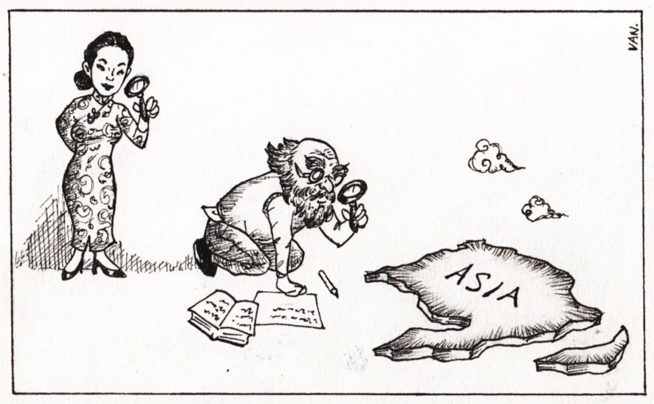
- Briefly explain how David Lodge, in his essay “The New Novel”, engages with Roland Barthes’s and Paul de Man’s formulations about the “impersonality and fictiveness of literary discourse”. Does Lodge succeed in liberating the author from “the epistemological skepticism of contemporary critical theory”?

III. Read the following excerpt taken from Stuart Hall’s introduction to his book Representation and answer any ANY ONE of the questions that follow in 150-175 words each. (1x10=10 Marks)

One soon discovers that meaning is not straightforward or transparent, and does not survive intact the passage through representation. It is a slippery customer, changing and shifting with context, usage and historical circumstances. It is therefore never finally fixed. It is always putting off or 'deferring' its rendezvous with Absolute Truth. It is always being negotiated and inflected, to resonate with new situations. It is often contested, and sometimes bitterly fought over. There are always different circuits of meaning circulating in any culture at the same time, overlapping discursive formations, from which we draw to create meaning or to express what we think.
Moreover, we do not have a straightforward, rational or instrumental relationship to meanings. They mobilize powerful feelings and emotions, of both a positive and negative kind. We feel their contradictory pull, their ambivalence. They sometimes call our very identities into question. We struggle over them because they matter- and these are contests from which serious consequences can flow. They define what is 'normal', who belongs and therefore, who is excluded. They are deeply inscribed in relations of power. Think of how profoundly our lives are shaped, depending on which meanings of male/female, black/white, rich/poor, gay/straight, young/old, citizen/alien, are in play in which circumstances. Meanings are often organized into sharply opposed binaries or opposites. However, these binaries are constantly being undermined, as representations interact with one another, substituting for each other, displacing one another along an unending chain. Our material interests and our bodies can be called to account, and differently implicated, depending on how meaning is given and taken, constructed and interpreted in different situations. But equally engaged are our fears and fantasies, the sentiments of desire and revulsion, of ambivalence and aggression. The more we look into this process of representation, the more complex it becomes to describe adequately or explain…

- Throughout this passage, Hall discusses the indeterminacy and ambivalence of meaning. Why is the indeterminacy of meaning central to post-structuralist thought? What makes such an understanding “post-structuralist” in nature?

- Deconstructionist criticism points out how meaning is constructed through binary oppositions. How do such binaries create a contextual meaning – negotiated by or replicating – extant power relations within/outside a text? Briefly elaborate using a book you have read or a film which you have recently watched.

