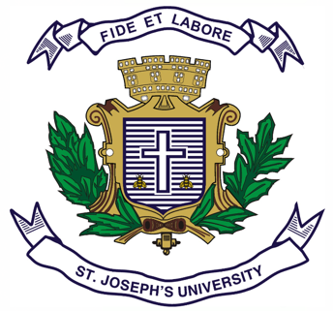
ST.JOSEPH’S UNIVERSITY, BENGALURU - 27
Registration Number:
Date & session: 16-12-2022 (1 PM)
B.A. (HISTORY) – I SEMESTER
SEMESTER EXAMINATION: OCTOBER 2022
(Examination conducted in December 2022)

HS 1221 – CULTURAL HERITAGE OF INDIA

Time: 2 Hours Max Marks: 50
This question paper has 1 printed page and 4 parts

SECTION - A
Answer any 2 of the following (2 x 10 = 20)
- State the importance of Cultural Heritage. Explain the different types
of culture with examples.
2. Explain the significance of Onam and Dusshera.
3. Discuss the importance and significance of Rath Yatra and Kumbh Mela.

SECTION - B (5 + 5 = 10)
4. Mark on the outline map provided the following places and write their historical importance.
1. Edakkal 2. Mahabalipuram 3. Manipur 4. Chittor 5. Konarck

SECTION - C
Answer any 2 of the following (5 x 2 = 10)
5. Describe Bharatanatyam.
6. Buddha Purnima.
7. Write a note on Pushkar mela.

SECTION - D
Answer any 5 of the following questions (2 x 5= 10)
8. Mention any two characteristics of Culture.
9. Why is Christmas an International festival ?
10. Guru Parb.
11. Baisaki.
12. Garba dance.
13. Kathak.
14. Name two foreign counties where Diwali is celebrated?

*****************

