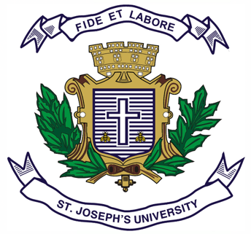
ST.JOSEPH’S UNIVERSITY, BENGALURU - 27
Registration Number:
Date & session: 21-12-2022 (1PM)
B.A. (HISTORY) – I SEMESTER
SEMESTER EXAMINATION: OCTOBER 2022
(Examination conducted in December 2022)

I Semester – OPEN ELECTIVE
HSOE 1 : TOURISM IN KARNATAKA
Time: 2 Hours Max Marks: 50
This question paper has 1 printed page and 2 parts

SECTION - A
Answer any 10 of the following (2 x 10 = 20)
1. Karunadu.
2. Mention any 2 ancient works which mention the name Karnataka.
3. What is KSTDC ? Mention any 2 objectives.
4. Mention any 4 infrastructure needed for tourism.
5. Golden Chariot.
6. GIT
7. Dasara Utsav.
8. Mention any 4 beaches in Karnataka.
9. Bidri Ware.
10. What is a World Heritage Site ? Mention the sites in Karnataka.
11. Mention any 2 wild life sanctuary in Karnataka.
12. Types of modern travel.

SECTION - b
Answer any THREE of the following questions (10 x 3 = 30)
- Explain any 10 kinds of Tourism with suitable examples.
- Describe travel in ancient times.
- State the significance of festivals in Karnataka. Explain any 4 festivals.
- Describe Adventure tourism in Karnataka with suitable examples.
- Write a note on the different cuisines of Karnataka.

*****************

