Registration Number:
Date 6-12-2022 ( 1 PM )

ST. JOSEPH’S UNIVERSITY, BENGALURU -27
M.Sc (Computer Science) – I SEMESTER
SEMESTER EXAMINATION: OCTOBER 2022
(Examination conducted in December 2022)
CS 7221: THEORY OF COMPUTATION

Time: 2 Hours Max Marks: 50

This paper contains 3 printed pages and 3 parts

PART-A

Answer all FIVE questions (1 X 5 = 5)

- Write the notations to represent Automata.
- Construct a MOORE Machine that prints a string “a” whenever the sequence 01 is encountered on any input binary string.
- Define Kleen closure.
- Define Nullable variable.
- Explain Final state Acceptance by PDA.
PART- B
Answer any FIVE questions (3 X 5 = 15)
- Write the ∈ -Closure for all the states of the following ∈ -NFA.
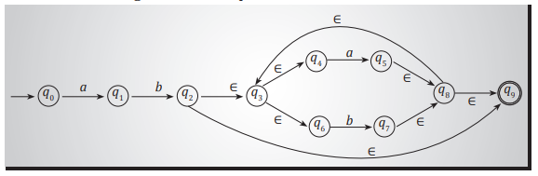
- Obtain a DFA to accept strings of 0's and 1's starting with at least two 0's and ending with at least two 1's.

- Derive the string 0111 00 from the following grammar,
S → 0 S 1 S | 1 S 0 S | ∈
and draw the parse tree.

- What is an Ambiguous Grammar? Explain with an example.

- Eliminate useless symbols from the following productions
S → aAa
A → Sb
A → bCC
A → DaA
C → abb
C → DD
E → aC
D → aDa
- Reduce the following grammar G to CNF.
S → a A D
A → a B | b A B
B → b
D → d
- Explain Turing Machine and Language acceptance of TM.

PART- C

Answer any THREE questions (10 X 3 = 30)

- a. Convert the following NFA to DFA using Subset method. [7 Marks]
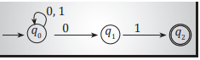
b. Define Extended transition function and check whether the string 000101 is accepted by the above DFA. [3 Marks]

- a. Minimize the following DFA. [7 Marks]

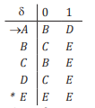
b. Define GNF. [3 Marks]

- a. Explain Chomsky hierarchy of generative grammars. [7 marks]
- Prove that the following language is not regular. WW^{R} Where W belongs to (a+b)*.
[3 Marks]
- a. Obtain a PDA to accept the language L(M) = { w c w^{R} | w ∈ (a + b)* } where w^{R} is the reverse of w. Check whether the string abcba is accepted by the PDA.
[6 marks]

- Construct an NFA with moves for the RE (a+b)* cd [4 Marks]

