ST. JOSEPH’S UNIVERSITY, BENGALURU -27
Registration Number:
Date & Session: 8-12-2022 ( 1pm)
M.Sc. – I SEMESTER
SEMESTER EXAMINATION: OCTOBER 2022
(Examination conducted in December 2022)
CS 7321 –Design and Analysis of Algorithms

Time: 2 ½ Hours Max Marks: 50
This paper contains 2 printed pages and 3 parts

PART-A
Answer all THE questions (5 X 1 = 5)
- Give an example of sorting algorithm for Divide and Conquer method?
- Identify the approach of Floyd Warshall algorithm.
- Which notation gives the worst-case complexity of an algorithm ?
- Find how many bins required from the given weight and capacity.
weight [] = {4, 8, 1, 4, 2, 1}, Bin Capacity c = 10
- Name any two NP Complete Problems.
PART- B
Answer any FIVE questions (5 X 3 = 15)
- How will you define asymptotic notations with growth functions and explain it with mathematical representation.
- Define an algorithm? Write a recurrence relation for binary search and analyze it.
- Consider fractional Knapsack problem and find the optimal solution using decreasing order of profits, where M = 15 ,(p1,p2,p3…p7) = (10,5,15,7,6,18,3) and (w1,w2….w7) =(2,3,5,7,1,4,1).

- Solve the following problem using Djikstra algorithm
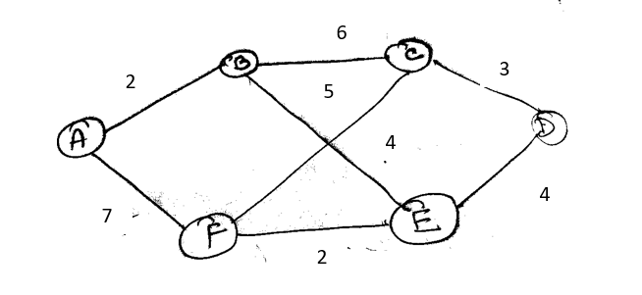

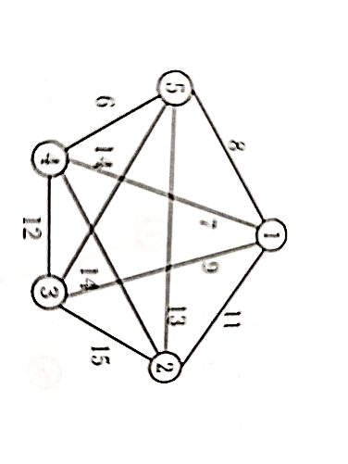
- Explain Hamiltonian cycle with an example
- Discuss about BFS algorithm and its applications.
- Find the minimum cost spanning tree using kruskal ‘s method

PART- C
Answer any THREE questions
(3 X10 = 30)

- Sort the following elements using merge sort algorithm and trace it
40 60 30 50 10 20 (5 Marks)
- Explain about Floyd Warshall algorithm (5 Marks)

a) Explain graph coloring problem (3 marks)
b) Explain 8 Queens Problem with an example (7 marks)

- Solve the following travelling salesman Problem using branch and bound technique
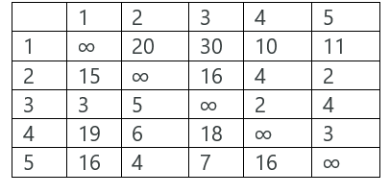
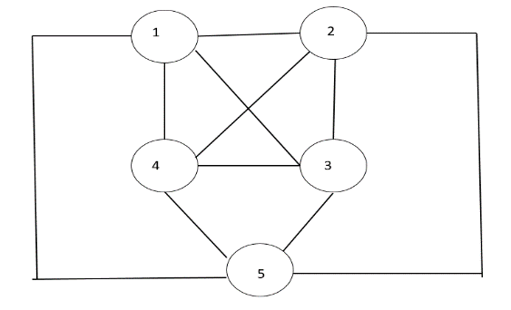

a) Elaborate non deterministic algorithm (5 Marks)
b) Cook Theorem (5 Marks)

