16-12-2022
ST. JOSEPH’S COLLEGE (AUTONOMOUS), BANGALORE- 27
END SEMESTER EXAMINATION - DECEMBER 2022
V SEMESTER CONTEMPORARY INDIAN LITERATURE (OE 5322)

TIME: 2 ½ hours Max marks: 70

INSTRUCTIONS
1. This elective paper is for students of V semester TEP Optional English.
2. The paper has THREE SECTIONS.
3. This question paper has FOUR printed sides.
4. You will lose marks for exceeding word limits.
5. You are allowed to use a dictionary during the examination.

PART A
Below is an extract from, “Ethnolinguistic Nationalism and Ethnic Conflict in Sri Lanka” by Neil DeVotta.
Given that claims to a historical homeland help to solidify nationalist aspirations, it is not surprising that both the Sinhalese and the Tamils declare themselves to be the island’s original settlers. The Sinhalese point to a mythical account in the Mahavamsa—a historical chronicle apparently written to legitimize Buddhism’s prominence in the island—and claim that their North Indian/Aryan ancestors were the first to reach Sri Lanka’s shores almost 2,500 years ago. According to this colonization myth’s most popular account, the founder of the Sinhalese race, Prince Vijaya, arrived on the island with 700 followers after being exiled by his father.
The Tamils claim that their Dravidian South Indian ancestors were the first to land on the island. Common sense suggests that if aborigines reached the island continent of Australia almost 40,000 years ago, and de- termined settlers crossed the Pacific Ocean to reach America’s western coast at least 13,000 years ago, then it is highly unlikely that South Indi- ans were unaware of an island situated only twenty-two miles across the shallow Palk Strait. A.L. Basham argued that “Dravidian infiltration into Ceylon must have been going on from the earliest historical times and probably before.”8 Some claim that only Dravidians settled the island, but Buddhism and its Pali scriptures created an “ascriptive cleavage” to divide the Dravidians into Sinhalese and Tamils. According to Satchi Ponnambalam, “The Sinhalese, then, in terms of their origin, are not an Aryan people as popularly claimed, but Tamil people who adopted a language which developed from Pali, an Aryan dialect.”9 Such assertions infuriate the Sinhalese.
These claims and counterclaims aside, there is little doubt that contemporary Sri Lankans are of mixed ethnic background. From Sri Lanka’s ruling elite to its lowliest classes, miscegenation, conversion, and acculturation appear to have been common over the centuries. As a result, contemporary “Sinhalese and Tamil labels are porous sieves through which diverse groups and categories of Indian peoples, intermixed with non-Indians . . . , have passed through.”
The account of the Buddhist warrior king Dutthagamani (second century b.c.) in the Mahavamsa, likely extrapolated from a historical event but certainly embellished thereafter, describes how the king, his army, and 500 Buddhist monks battled and defeated the Chola king Elara, who had usurped the power of the Anuradhapura kingdom. Nineteenth- and twentieth-century Sinhalese elites characterized the event as a valiant contest between Sinhalese and Tamils. The activist scholar-monk Walpola Rahula maintained that “the entire Sinhalese race was united under the banner of the young Gamini [Dutthagamani]. This was the beginning of nationalism among the Sinhalese. It was a new race with healthy young blood, organized under the new order of Buddhism. A kind of religio-nationalism, which almost amounted to fanaticism, roused the whole Sinhalese people. A non-Buddhist was not regarded as a human being. Evidently all Sinhalese without exception were Buddhists.” Yet as one author has correctly observed, “The facile equating of Sinhalese with Buddhist [sic] for this period is not borne out by the facts, for not all Sinhalese were Buddhist, while on the other hand there were many Tamil Buddhists.”
The Dutthagamani account had a powerful impact on the modern Sinhalese Buddhist psyche, and Sinhalese ethnic entrepreneurs appealed to the account’s divisive emotions to portray themselves as defenders of Buddhism and the Sinhalese race. These elites blended folklore and religion to fashion a nationalist ideology that promoted the belief that Sri Lanka was Sihidipa (the island of the Sinhalese) and Dhammadipa (the is- land chosen to preserve and propagate Buddhism). This led to the claim that “for more than two millennia the Sinhalese have been inspired by the ideal that they were a nation brought into being for the deanite purpose of carrying the torch lit by the Buddha.” Walter Schwarz has astutely observed that “the most important effect of the early history on the minority problem of today is not in the facts but in the myths that surround them, particularly on the Sinhalese side.”
I.A. Answer the following questions in 5-6 sentences each (4x5=20)

- What is ‘Dravidian Infiltration’ of Sri Lanka?
- Why does the author compare contemporary Sri Lank to a ‘porous sieve’?
- Which is the historical juncture that Walpola Rahula claims to be the root of Sinhalese nationalism?
- Do you agree that myths have a significant role in constructing identities? Discuss with an example.

PART B
II.B. Answer any TWO questions in 150 words each (2x10=20)

- What is ‘Urban Buddhism’ as observed by Subramanian in Colombo city? What is the role of modern Buddhist shrines in this context?
- ‘Bombay…had always been there in the way that, when we are twenty, cities loom on our horizons and we imagine comfortably distant futures in which we might live in one of them.’ In the story Revolutions, how does Sceince’s behavior and conduct suggest youthful urban aspirations?
- According to Ramchandra Guha, the global history of cricket is interlinked to the questions of race conflict, class conflict, communal conflict, caste conflict and national conflict. Do you agree with Guha’s observation? Argue.
- The writings of Anjum Hassan and Nisha Susan capture the experiences of individuals interacting in an urban-digital landscape. Drawing references from stories Revolutions and No Filter discuss the above statement.

PART C

III.C. Answer any TWO questions in 200 words each (2x15=30)

- ‘In the 1860s upper-caste women barely left the house, let alone traveled overseas to study. Educating a girl was considered unnecessary; educating them in the sciences even more so. Amongst Hindus, it was considered unlucky to let girls remain unmarried after the age of ten. Girls would often be married and widowed before they were twelve, then spend the rest of their lives in poverty. Across the world, medical colleges banned women from attending.’ Discuss the implications of the socio-political climate of the late 19th century on women’s education? What is the critical salience of writing about ‘Lady Doctors’ who broke conventional understanding of womanhood?
- The works of Kavita Rao, Nisha Susan, Anjum Hassan and Shrayana Bhattachary explore ideas of womanhood, their struggles and desires. Discuss three examples from the works of these authors that you think pushes the understanding of what it means to be a woman in contemporary times.

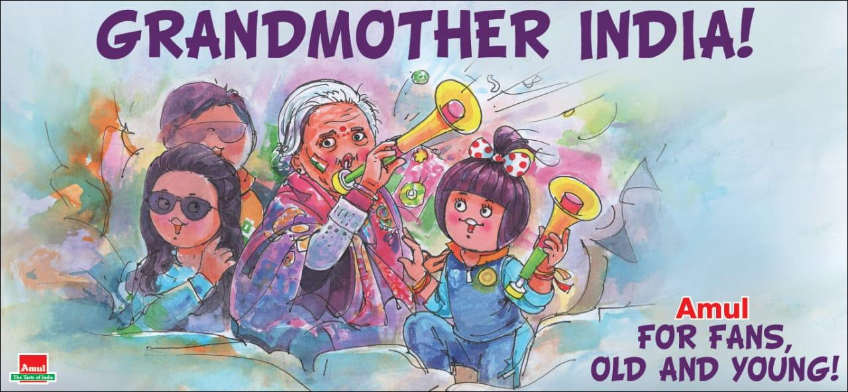

- This cartoon by Amul commemorates the 87 year old Charulatha Patel who was found cheering for India against Bangladesh during the ICC Men’s Cricket World Cup 2019. Do you agree that cricket is a great equalizer in the sub-continent? Narrate your personal experience with cricket?

***

