ST. JOSEPH’S COLLEGE (AUTONOMOUS), BENGALURU -27
Registration Number:
Date & Session: 13-12-2022, 9 am
B.Sc (BIOTECHNOLOGY)– III SEMESTER
SEMESTER EXAMINATION: OCTOBER 2022
(Examination conducted in December 2022)
BT 322 – BIOMOLECULES AND BIOSTATISTICS

Time: 2 Hours Max Marks: 60
This paper contains THREE printed pages and THREE parts

PART-A
Answer any TEN of the following: 10 x 2 = 20 marks

- Match the types of graphs in column ‘A’ with their associated elements in column ‘B’:
Column A | Column B
i) Ogives | - Representing multiple variables in a graph
ii) Divided bar graph | - Continuous data
iii) Pie chart | - Quartiles
iv) Histogram | - Sectors of a circle
 | - Cumulative frequency

- Using the relationship between arithmetic mean, median, and mode in a skewed distribution, calculate the arithmetic mean when the mode is 11 and median is 14.

- Standard deviation is a widely used measure of dispersion, and it is the square root of variance. What is the disadvantage of using variance as a measure of dispersion while dealing with biological data?

- Explain briefly, cluster sampling and systematic sampling techniques.

- Differentiate between positive and negative correlation. What can you infer from the statement “Two variables have a Pearson’s correlation coefficient of +1”?

- A pharmaceutical company is testing a new drug for diabetes. Identify the statistical test of significance (given the options of Student’s t-test, analysis of variance, and Chi-square test) that you would employ in order to analyze the quantitative results of this experiment, in the following two scenarios:
a. While conducting experiments using two groups of mice, one receiving the drug, and another ‘control’ (will not receive the drug).
b. While testing four different concentrations of the drug, on experimental animals.

- Why are deoxyribonucleic acids called acids? Draw the structure of a nucleotide.

- Briefly describe the role of NADH as a coenzyme.

- What are reducing sugars? Draw the structure of a non-reducing sugar.
- Briefly explain the Urey Miller experiment.
- What is protein denaturation and renaturation?
- What is salting-out?
Part-B
Answer any FOUR of the following: 4 x 5= 20 marks
- The following data represents leaf areas measured in a sample of plants.
Leaf area (X) (in cm2) | 3 | 4 | 5 | 6 | 7 | 8 | 9
Frequency (f) | 2 | 3 | 6 | 8 | 7 | 2 | 1
(a) Find out the mode of the given data using grouping and calculation tables. (4 marks)
(b) Calculate the range of this distribution. (1 mark)
- (a) What is probability distribution? Draw a frequency polygon to represent normally-distributed observations, and mention the proportions of data-points expected within one and two standard deviations from the mean. (3 marks)
(b) Among the twenty naturally occurring L-amino acids, there are three basic amino acids. How many types of tripeptides (a chain of three amino acids) are possible which contain only the basic amino acids? Find out the possible permutations of tripeptides containing basic amino acids. (2 marks)
- (a) The following graph represents the variation of optical density/absorbance of protein solutions of different concentrations. Analyze the graph and identify the type of correlation represented, in relation to the types given below. (2 marks)
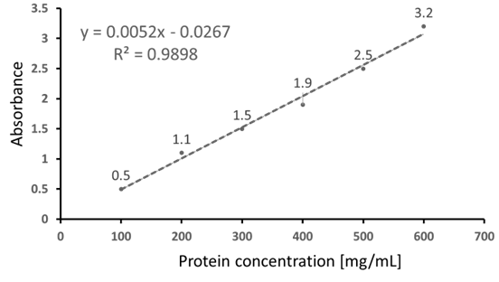
(i) Simple or multiple correlation
(ii) Linear or non-linear correlation

(b) Using the given equation, calculate the concentration of a protein solution which has an optical density of 2.4. (2 marks)
(c) The value of R² for the curve shown here is 0.9898. If another line was plotted, with an R² value of 0.75, which one would be the more accurate regression line? (1 mark)
- Compare and contrast the types of DNA.
- Write a note on the structure and functions of the storage polysaccharide in plants.
- Explain in detail the types of reversible enzyme inhibitions.
Part-C
Answer the following: 2 X 10 =20 marks
- (a) The following data represents butterfly wing-lengths (in cm).
Wing lengths (X) | 3 | 4 | 5 | 6 | 7 | 8 | 9
Frequency (f) | 2 | 3 | 6 | 8 | 7 | 2 | 1
i. Calculate the standard deviation of the given wing-lengths. (5 marks) ii. Draw a frequency polygon to represent the given data. (2 mark)
iii. Based on the frequency polygon, do you agree with the hypothesis that butterfly wing-lengths are normally distributed? Why or why not? (3 marks)

Or
(b) i. In a Mendelian experiment on breeding, four types of plants are expected to occur in the proportions of 9:3:3:1. In a random sample of 1616 plants, the observed frequencies are 891 (round-yellow), 316 (wrinkled-yellow), 290 (round-green), and 119 (wrinkled-green). Find out the chi-square value and examine the correspondence between the expected and observed frequencies. [Consider the table value of chi square to be 7.815 ] (6 marks)
ii. In the given sample, find out the probability of a randomly picked plant to be of round-yellow type. (1 mark)
iii. What is a random sample? What will be the consequence of not considering a random sample in an experiment? Mention any one methods of obtaining a random sample. (3 marks)

- (a) Classify amino acids based on their polarity. Draw the structure of any one amino acid from each class.
or
(b) What are compound lipids? Explain the properties of triacylglycerols.

