ST.JOSEPH’S UNIVERSITY, BENGALURU -27
Registration Number:
Date & session:5-12-2022 (9am)
B.Sc. (BIOLOGY) – I SEMESTER
SEMESTER EXAMINATION: OCTOBER 2022
(Examination conducted in December 2022)
BY 122 – BIOLOGY I

Time: 2 Hours Max Marks: 50

This paper contains TWO printed pages, TWO sections, and THREE parts in each section

SECTIONS I AND II HAVE TO BE WRITTEN IN SEPARATE ANSWER BOOKLETS

SECTION I : (BOTANY)

Part A: Answer any FIVE of the following in one or two sentences each: 5 x 1 = 5 marks

- Capillitium
- Dolipore septa
- Prosenchyma
- Cleistothecium
- Hypertrophy
- ‘Witches broom’
- Bordeaux mixture

Part B: Write notes on any TWO of the following: 2 x 5 = 10 marks

- Methods of asexual reproduction in fungi (any 5)
- Life cycle of Puccinia in the wheat plant
- V.S. of apothecium in Lichens

Part C: Give a comprehensive account of any ONE of the following: 1 x 10 = 10 marks

- Morphology and sexual reproduction in Rhizopus
- Causal organism, symptoms and control of Red Rot of Sugarcane

SECTION II : (ZOOLOGY)

Part A: Answer any FIVE of the following 5 x 1 = 5 marks

1. Who coined the term species?
2. How many rayed spicules are found in glass sponges?
3. Give an example for colonial flagellate
4. Name the cells that produce the spongin fibers in poriferans
5. Why phylum Nematoda are known as pseudocoelomates?
6. Name the infective larval stage in the life cycle of Ancyclostoma
7. Differentiate between Scyphozoan and Anthozoans

Part B: Answer any TWO of the following: 2 x 5 = 10 marks

8. Draw a neat labelled diagram of trophozoite stage of malarial parasite
9. Depict the life cycle of Aurelia with a neat labelled diagram
10. Identify the organism shown in the picture and discuss its polymorphism
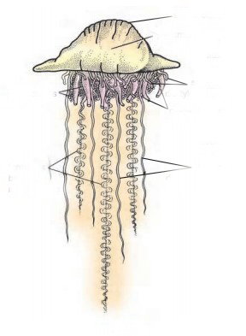

Part C: Answer any ONE of the following: 1 x 10 = 10 marks

11. Diagrammatically explain the mode of infection of Ascaris in its host
12. Canal system is an efficient water vascular system in sponges. Explain with diagrams and examples

