**ST.JOSEPH’S UNIVERSITY, BENGALURU -27**

Registration Number:

Date & session:13-12-22

**M.Sc (ZOOLOGY) – I SEMESTER**

**SEMESTER EXAMINATION: OCTOBER 2022**

**(Examination conducted in December 2022)**

**Z07522 – ANIMAL BEHAVIOUR**

**Time: 2 Hours Max Marks: 50**

**This paper contains THREE printed pages and FOUR parts**

**PART-A**

**Answer the following 5 x 1 = 5**

1. ____________ trophallaxis is related to the exchange of food among the members through mouth to mouth.
2. Give an example of brood parasite.
3. Where is Hippocampus located in human brain?
4. What is a flehmen response?
5. Define the term human behaviour.

**PART- B**

**Answer the following 5 x 2 =10**

1. Define kinesis and mention its types.
2. Write any two differentiating characters of soldier and worker of termites?
3. Leks
4. Hamilton’s rule
5. Optimal foraging theory

**PART- C**

**Answer any three of the following 5 x 3 =15**

1. Identify the ethologist and comment on the type of behaviour in the picture.

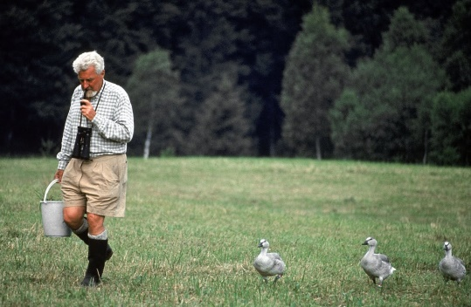

1. Comment on the behaviour in the picture

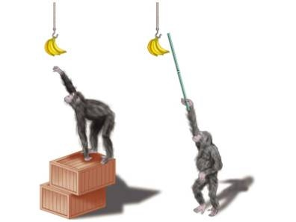

1. Identify and briefly explain the types of mating system in primates given in the image A, B, C.

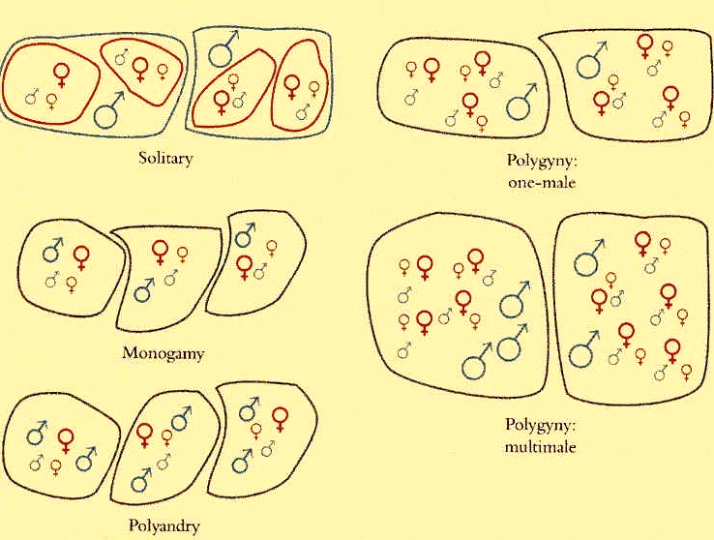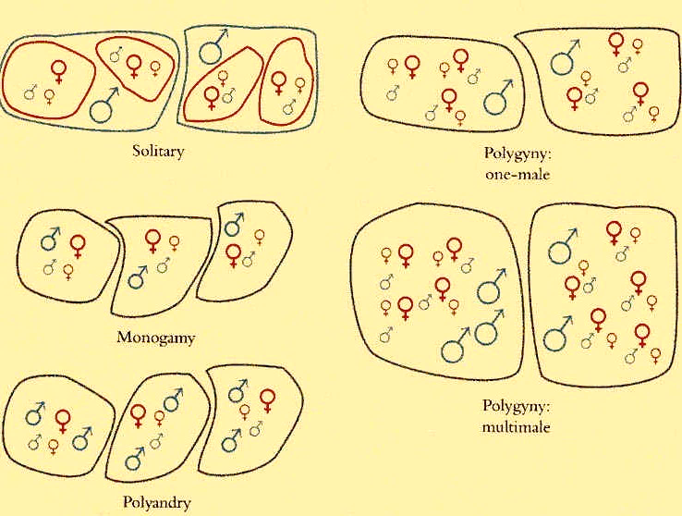

A

**Bv**

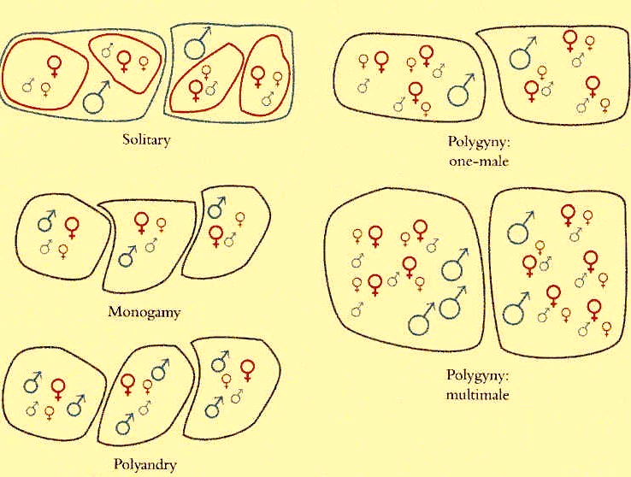

**Cv**

1. How is parental investment advantageous as an behaviour?

**PART- D**

**Answer any two of the following 2 x 10 =20**

15. Provide two examples of learned cooperative foraging behaviours in Dolphins

16. Discuss in detail the objectives of studying animal behaviour.

17. Identify the type of model of optimal foraging theory shown in the picture below and answer the following questions

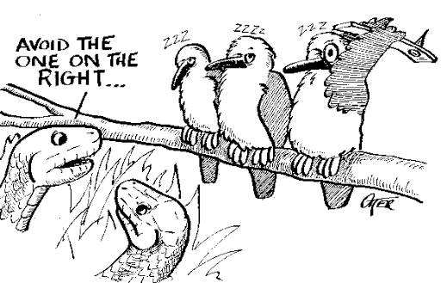

1. Briefly explain the factors involved in model building process of foraging.
2. Explain why the predators avoid the prey sitting on the right side in the picture (give the equations also)?