ST. JOSEPH’S UNIVERSITY, BANGALORE-27
BCA- II SEMESTER
SEMESTER EXAMINATION: APRIL 2023
(Examination conducted in May 2023)

CA2321- DISCRETE MATHEMATICAL STRUCTURES
Time- 2 Hrs. |  |  | Max Marks-60
This question paper contains three parts.
Register Number:
Date:

PART A
Answer all the five questions. (5*2=10)
1. If A= {1,2,3} ,B={3,4,5} and C={0,2,3} the find (A ∩ B) X C.
2. How many unique 3 digit codes can be created from the 5 digits {1,2,3,4,5}if repeats are possible?
3. What is the number of possible words that can be made using the word “QUIZ” such that the vowels never come together?
4. If A = {a, b, c, d} and the function f = {(a, b), (b, d), (c, a), (d, c)}, Find the value of f ^{– 1}
5. How many Hamiltonian paths does the following graph have? Find them.
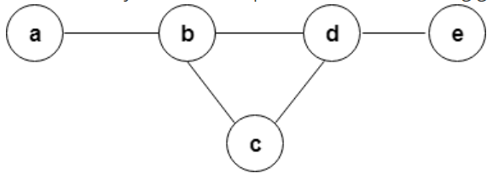

PART B
Answer any five of the following questions. (5*4=20)
6. What makes the function recursive? Explain any one recursive algorithm.
7. Prove that p v (q ^ r)↔ {(p v q) ^ (p v r)} is tautology
8. Determine in how many ways can three gifts be shared among 4 boys in the following conditions-
i) No one gets more than one gift.
ii) A boy can get any number of gifts.
9. Prove using mathematical induction 1+2+3+4+5+6+…….+n=n(n+1)/2
10. Write an algorithm to sort a list of elements using Merge Sort(Use Divide and Conquer technique)
11. Consider the following graph-
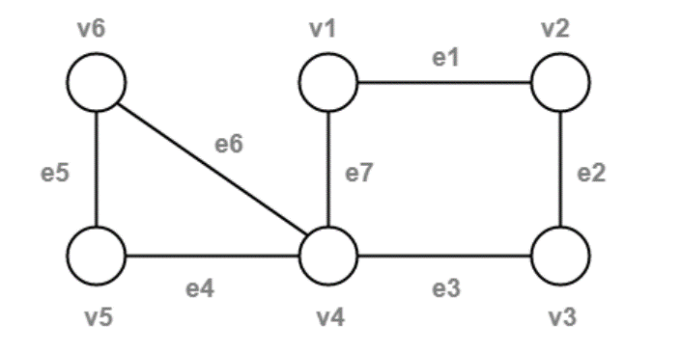
Observe the given sequences and predict the nature in each case(whether it’s a walk/path/circuit).justify your answer.

CASE1: v4e7v1e1v2e2v3e3v4e4v5
CASE2: v1e1v2e2v3e3v4e4v5
CASE3: v1e1v2e2v3e3v4e7v1
CASE4: v6e5v5e4v4e3v3e2v2e1v1e7v4e6v6 [4]
12. Are the following two graphs isomorphic? Explain your answer with supporting statements.
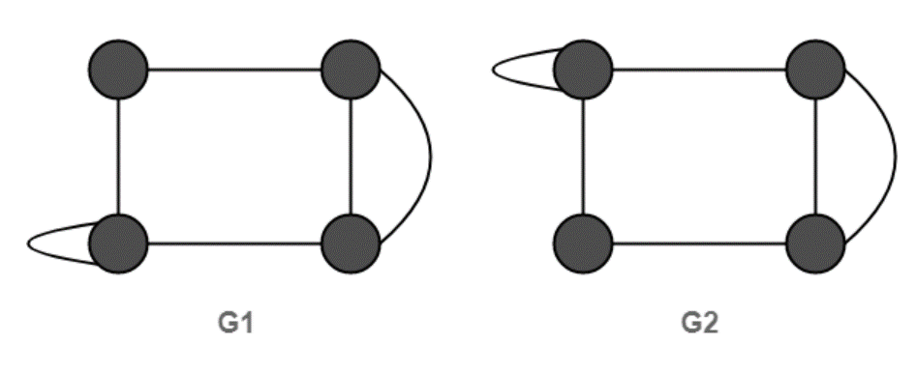 [4]

PART B
Answer any three of the following questions. (3*10=30)
13.a. Check whether the relation R in the set{1,2,3} given by R={(1,2),(2,1)} is reflexive symmetric or transitive.
b. If X and y are the two finite sets, such that n(X U Y) = 36, n(X) = 20, n(Y) = 28, then find n( X ∩ Y).
c. Expand (5x+2y)⁴ using Binomial Coefficient.
[3+3+4]

14. a. Explain Pigeonhole principle.
b. Find out the number of ways that the letters of the word “LEADER” can be arranged?
[3+7]
15. a. What is a Planar Graph? What are the steps involved to detect planar graphs?

b. If A= {1,2,3,4} and R and S are two relations on set A defined by R={(1,2),(1,3),(2,4),(4,4)} and S={(1,1),(1,2),(1,3),(1,4),(2,3)}.
Find S o (R o R) and R o R [5+5]
16. a. A drawer contains 12 red and 12 blue socks, all unmatched. A person takes socks out at random in the dark. How many socks must he take out to be sure that he has at least two blue socks?

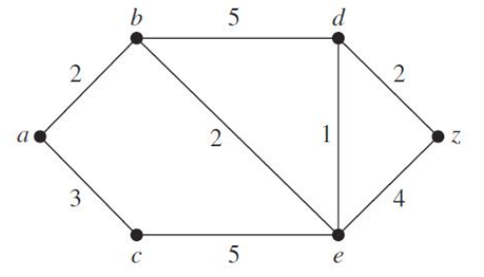
b. Find the length and shortest path between a and z in the weighted graph given below:

[3+7]

*******************************************************************************************************

