Registration Number:
Date & Session:

ST. JOSEPH’S COLLEGE (AUTONOMOUS), BENGALURU -27
B.Sc (BIOCHEMISTRY)– IV SEMESTER
SEMESTER EXAMINATION: APRIL 2023
(Examination conducted in May 2023)
BCH 422 – Biomolecules and analytical techniques in biochemistry - 1

Time: 2 Hours Max Marks: 60
Instructions:1. This paper contains four printed pages and three parts.
2. IR and proton NMR data are given at the end of the question paper

PART-A

Answer any TEN of the following questions.(10X2=20M)

- How do both polar and nonpolar compounds stabilize in water as a solvent in biological systems?
- Draw the furanose structure of fructose and identify its anomeric carbon.
- What are the advantages of studying X-ray diffraction of biomolecules?
- State Stark-Einstein law of photochemical equivalence.
- How are atomic spectra different from molecular spectra?
- Between 1,4-pentadiene and 1,3-pentadiene, which compound would absorb at higher wavelength and why?
- What does ELISA stand for? What is its application in investigation of biological samples?
- What is Raman effect?
- What type of nuclei are NMR active? Which among ²H₁, ⁴He₂, ¹²C₆ is/are NMR active?
- What does TMS stand for and what is it used for in ¹H-NMR spectroscopy?
- Calculate the chemical shift value of a set of protons which resonated at 2181 Hz when measured using a spectrophotometer operating at 300 MHz.
- What is soft ionization technique in mass spectrometry?

PART-B

Answer any FIVE of the following questions.(5x6=30M)

- (a) Draw the partial structure of chondroitin sulphate. What is its biological role?
(b) List the functions of cholesterol. (3+3)
- Which are the regular secondary structures proteins exhibit? What are the differences between these secondary structures? Which non covalent interaction stabilizes them? Which functional groups of amino acids are involved in this noncovalent interaction?
- (a) Explain shielding and deshielding of protons with suitable examples.
(b) How do you distinguish 1º, 2º and 3º amines by IR spectroscopy?(3+3)
- (a) What is the difference in the signal for -OH proton in ¹H-NMR spectrum for a pure sample of ethanol and an impure sample of ethanol (with acidic impurity)?
(b) How many signals do you expect in ¹H-NMRspectrum of the compound 1,1,2-trichloroethane? What is the multiplicity of these signals?(3+3)
- What do you mean by a base peak and a molecular ion peak in mass spectrometry? Mass spectrum of n-hexane shows prominent peaks at m/z 86, m/z 71, m/z 57, m/z 43 and m/z 29. What do these peaks correspond to?

- (a) What is the difference between chemiluminescence and bioluminescence? Give an example of bioluminescence.
(b) Give Jablonski diagram representing different physical and chemical processes molecules undergo upon absorption of a photon.(3+3)
- (a) What are Schottky& Frenkel defects in crystalline solids?
(b) Name any three crystal systems and their dimensions. (3+3)

PART-C
Answer any TWO of the following questions (2X5=10M)

- (a) Linseed oil is a triglyceride of glycerol with oleic, linoleic and linolenic acid. It is used to harden oil-based paints such as ‘artist’s oil paints. What may be the reason for this application of linseed oil?

(b) Evaluate the given data. Identify the more unsaturated oil and the oil with shorter carbon chain.(2+3)
Oil | Iodine number | Saponification number
Coconut oil | 7.5-10.5 | 246-260
Olive oil | 80-85 | 185-196

- (a) Is it possible to distinguish between ethanoic acid (CH₃COOH) and propanoic acid (CH₃CH₂COOH) by IR spectroscopy? Justify.
(b) Normal IR base values for carbonyl stretching are as follows: Amide 1690 cm⁻¹and ester 1735cm⁻¹. Reason out the differences in carbonyl frequency values. (2+3)

- The ¹H-NMR spectrumof an ester with molecular formula C₄H₈O₂is given below. What are the two possible structures A and B for the ester? Suggest which among A or B represents the ¹H-NMR spectrum given? Assign the signals to the suggested structure.
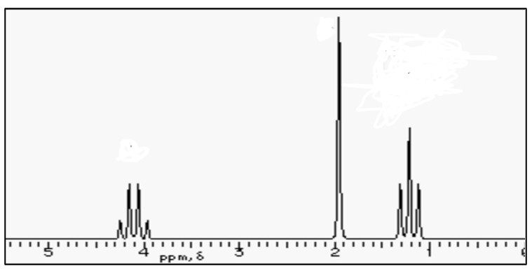

…………..End of questions………..

(Spectral data tables on the next page….)




