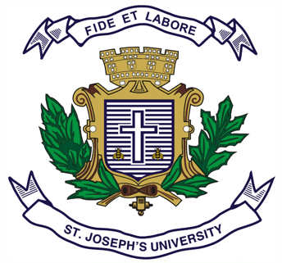
Date:
Registration number:

ST. JOSEPH’S UNIVERSITY, BENGALURU-27
B.A. VISUAL COMMUNICATION – II SEMESTER
END SEMESTER EXAMINATION: APRIL 2023
(Examination conducted in May 2023)
VC 2321 – HISTORY OF VISUAL ARTS
(For current batch students only)

Time: 2 hours
Max Marks:60

This question paper contains ONE printed page and THREE parts.

Please read the questions carefully.
Stick to the minimum and maximum word count for the answers.
Provide appropriate references and examples to support your answers.

- Write short notes on any THREE (100 to 150 words each) [5 x 3 = 15]

- Laocoon and His Sons
- Frescos
- Mastaba
- Natya Shastra

- Answer any THREE questions (200 to 300 words each) [10 x 3 = 30]

- What is the significance of the Ajanta caves to Indian art? Explain.
- Write a note on Mughal miniatures. Describe any one respective artefact.
- Point out any two differences between hieroglyphs and cuneiform.
- What is art? Explain citing two competent academic sources.

- Answer any ONE question (400 to 600 words) [15 x 1 = 15]

- What is Romanesque and Gothic architecture? Explain each citing two examples each.
- What is considered as Baroque art? Substantiate describing any three artefacts.
***

