St Joseph’s College (Autonomous)
Register No:
Date:
BA. Visual Communication – VI Semester
End Semester Examination
VC 6220 – Visual Aesthetics

Time: 2 ½ Max. Marks: 70
This paper contains ONE printed page and TWO parts.
- Answer any FOUR questions in about 200 words each: (4 x 10)
- Elucidate appropriate reflections on the phrase ‘Art for art’s sake’. How do these notions contribute to the advantages of artists?
- What is creativity and rasa as evolved from the readings of Indian aesthetics? Explain.
- Look at the following images (a) and (b) and derive your assumptions about various stylized visual representations associated with its times.
- (b)
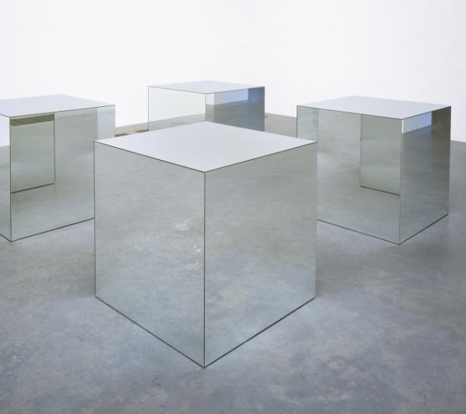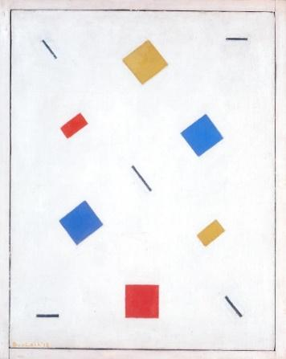
- What is philosophy? What are its branches?
- What is a photograph composed of and how are those compositions valued as a rhetoric of the image?
- How does male gaze in visual medium contribute to the objectification and alienation of women?

II. Answer any TWO of the following in about 350 to 400 words each: (2 x 15)
- Give a detailed view of Walt Disney’s evolution in the art and entertainment market.
- How does Ruchi Ravi Shewade establish that item songs in Hindi mainstream cinema have marginalised women? Summarise the arguments in her article.
- Discuss the six perspectives of visual analysis with reference to a known photograph OR film OR artwork.
- What is intertextuality? What are its types? Discuss the probable advantages of intertextuality in visual representations.

******

