Register Number:
Date:
ST. JOSEPH’S UNIVERSITY, BANGALORE - 27
I B.A – COMMUNICATIVE ENGLISH
END-SEMESTER EXAM: MAY- JUNE 2023
COMMUNICATIVE ENGLISH: CE 221
Time- 2 hours Max Marks- 60

Instructions:
- This paper is for students of II semester Communicative English.
- The paper has FOUR SECTIONS and THREE printed pages.
- You will lose marks for exceeding the word limit.
- You are allowed to use a dictionary.

- Read the following excerpt from an interview with Joe Sacco and answer the questions below.

Interviewer: Do you think there’s any advantage to the kind of storytelling you do?
JS: It’s a visual world and people respond to visuals. With comics you can put interesting and solid information in a format that’s pretty palatable. For me, one advantage of comic journalism is that I can depict the past, which is hard to do if you’re a photographer or filmmaker. History can make you realize that the present is just one layer of a story. I personally think that photographs and film can be very effective to depict a violent atmosphere, but sometimes they can show brutality so starkly that I feel a revulsion. Drawing somehow allows you to look. There’s enough of an unreality to it that you can look at things that, if you saw them in an image which purports to be real, you’d feel a need to turn away. Allowing a reader to peek through their fingers at the unspeakable atrocities of war isn’t the only advantage of comics journalism. It can show you things that the camera can never see, too. You don’t get cameras going into a torture chamber. There were no cameras going over the top at the Battle of the Somme.
Interviewer: When you’re out doing interviews, are you looking at people as an artist and sketching them at the same time?
JS: I tend to wear the hat of reporter more when I’m interviewing people. I’ll tape-record or take notes. I always ask a subject if I can take his or her picture. In about 90 percent of cases they’ll say yes, but when they say no, I’ll surreptitiously do a quick drawing. It won’t be such an exact likeness that they could be identified.
Interviewer: When you’re re-creating events you haven’t witnessed, do people ever challenge your portrayal of those scenes?
JS: I try to ask visual questions. I’ll ask what someone was wearing, if that seems relevant. If possible, I’ll walk over the same ground that they’re depicting. Of course, I can never get it precisely as it was. It’s like a film director trying to represent a scene that took place in the 1700s. You reconstruct it to the best of your ability.
Interviewer: You’re usually the most cartoony character in your stories—your glasses are blank, your facial features exaggerated, your limbs rubbery. Why depict yourself like that?
JS: When I started Palestine it was a bit rubbery and cartoony at the beginning, because that’s the only way I knew how to draw. It became clear to me that I had to push it toward a more representational way of drawing. I tried to draw people more realistically, but the figure I neglected to update was myself.

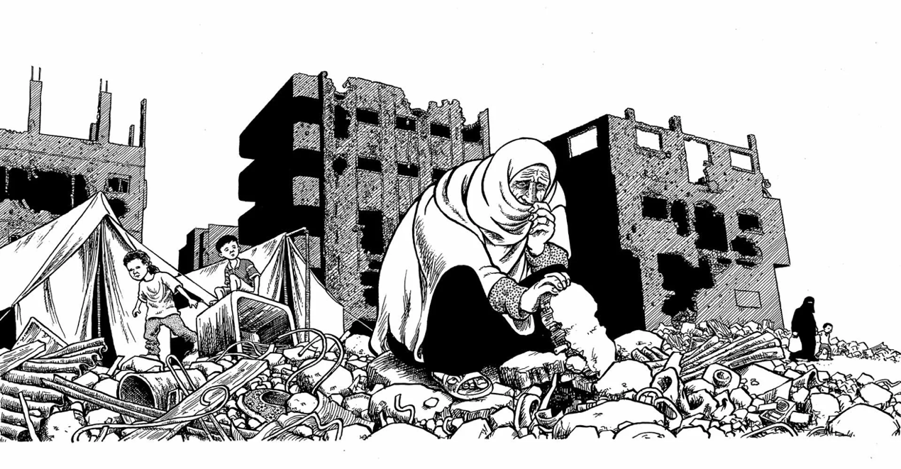

- Answer ANY FOUR of the following questions in FIVE to SIX lines. (4x5=20)

- Does drawing allow you to look at things that would be hard to look at in a photograph? Use the illustration above by Joe Sacco as reference and explain.

- What are some other advantages to comic journalism apart from the ones mentioned above? What else does it do that photographs cannot?

- What has been the biggest challenge for you when you went out to report on events and interview people? Have you been able to overcome it? Explain.

- Joe Sacco says he neglected to update himself when he was drawing the comics and that’s why his depictions of himself are plain. In what way did this affect your reading of Safe Area Gorazde?

- Write about a memorable panel from Safe Area Gorazde that can show us Sacco’s eye for detail.

- Read this news article from India Today and answer the questions below.

Angry camel killed his owner and sat on dead body till last breath
You may have heard many cases of camels but this Jaisalmer camel story is among the scariest ever. We are talking about a case 20 km away from Jaisalmer, in Basinpeer south village, where a domestic camel got so violent that he threw down his 25-year-old owner and crushed him to death. After killing his owner Ashok, the camel sat on his body for the whole night mercilessly.

On Thursday morning, Ashok's family members found him dead and the camel was sitting on his dead body. The camel was so much out of control that the villagers had to shoot the camel to take away the body. The animal had on an earlier occasion attacked the owner's father as well. Many times, the family members tried to sell the camel but the owner always refused to do so.

Former MLA Basinpeer confirmed the incident and said, "That evening Ashok was returning back home from his farm. It is to be believed that he was 2 km away from the village and then suddenly the camel got violent. The camel threw down his owner and killed him mercilessly. He must have cried or shouted a lot but nobody listened to him in the desert. Possibly it was late and dark, so he couldn't find any help". Villagers paid their heartfelt condolences and set the body on fire in the evening. It is to be believed that the camel was angry from the last 4-5 days.

Ashok had tied the camel’s mouth a few days ago fearing that the camel can hurt him any day. He tried to control the animal by beating him up but with no success. People often say that camels get angry upon not finding a mate. During the mating period it is very hard to control the animal. Last year on May 22 in Badmeir district, a camel had killed his owner just by biting him, says a report.

- Answer the following questions in 100-150 words each. (2x10=20)

- Read the headline carefully. What other key detail from the story would you have added in the headline? Give reasons.

- Could the piece have been structured better? Which details would you remove? Why? Explain.

- Identify plosive consonant sounds and write the voice, place, and manner of articulation for the following: (5 marks)

- Snack Table

- Transcribe the following to IPA: (5 marks)

- Ships at a distance

- Write 150-200 words in response to ANY ONE of the prompts below and draw an illustration to accompany it. You will not be marked on the quality of the illustration but the attempt. (10 marks)

- Pockets
- Eating sounds

****

