Registration Number:
Date & session:
ST.JOSEPH’S UNIVERSITY, BENGALURU -27
M.Sc (Computer Science) – II SEMESTER
SEMESTER EXAMINATION: APRIL 2023
(Examination conducted in May 2023)
CS8521 – SOFTWARE PROJECT MANAGEMENT
(For current batch students only)

Time: 2 Hours Max Marks: 50
This paper contains __2____ printed pages and ___3__ parts

PART A

ANSWER THE FOLLOWING QUESTIONS (5*2=10 MARKS )

1. Demonstrate with an example how a project is different from a job?
2. Management is essential for successful completion of a software project: justify this statement.
3. Define risks. Mention any two categories of risks.
4. Identify the team structure given below and mention any two characteristics of this team structure.

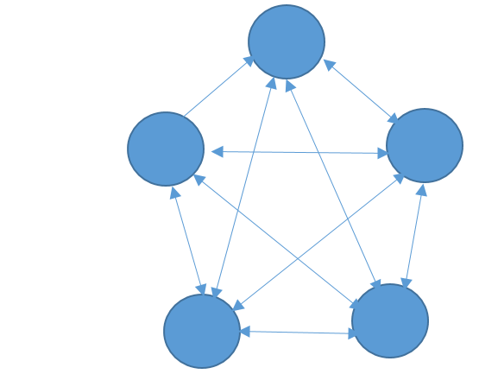
5. Define software quality.

PART B
ANSWER FIVE OF THE FOLLOWING QUESTONS (5*4=20 MARKS )
6. Give a note on different stages of management.
7. The mnemonic SMART is commonly used to describe objectives? What does SMART represent, give explanation.
8. Write a detailed note on Agile manifesto.
9. Explain the Raleigh Norden’s curve given below.
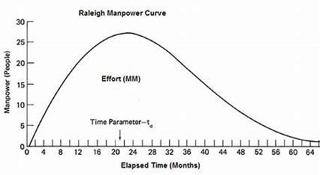
10.Parkinsons law states that “work expands to fill the time available” give an explanation for the same.
11.Write a note on importance of resource allocation and management in software projects.
12.Emphasise on the importance of health and safety of a software engineer in the workplace.
PART C
ANSWER ANY TWO OF THE FOLLOWING QUESTIONS (2*10=20 MARKS)
13. a) When is it appropriate to use spiral model. (2)
b) With a diagram explain the scrum frame work? (8)
14. a) List the features of top down approach. (2)
b) Mention all the categories of projects and explain the COCOMO model in detail. (8)
15. From the table given below
a) Draw the precedence network. (6)
b) Identify the critical path and justify the same. (4)
Activity | Duration in weeks | Precedents
A: hardware selection | 6 | -
B:system configuration | 4 | -
C:install hardware | 3 | A
D: data migration | 4 | B
E:draft office procedures | 3 | B
F:recruit staff | 10 | -
G:user training | 3 | E,F
H: install and test system | 2 | C,D

