Date:
Registration number:

ST. JOSEPH’S COLLEGE (AUTONOMOUS), BENGALURU-27
B.Sc. ELECTRONICS- IV SEMESTER
SEMESTER EXAMINATION: MAY/JUNE-2023
EL421- DATA ACQUISITION AND INSTRUMENTATION

Time- 2 hrs Max Marks-60

This question paper contains Three printed pages and Three parts

Part A
Answer all questions: 10 X 1 = 10

- A measuring instrument gives same measurement for a given input many number of times. We can conclude that the instrument has
a) Good accuracy b) Good precision
c) Good accuracy and poor precision d) poor accuracy and good precision.
- A photovoltaic cell act as a photo diode under the following condition.
a) when forward biased b) when reversed biased
c) when light falls on it d) irrespective of biasing
- Step size of a 4 bit DAC is 0.6 V, then the full scale output is
a) 2.4 V b ) 9.6 V c) 9 V d) 4.2 V
- In an 8 bit SAR ADC, full scale output of the internal DAC is 12 V. What is the analog input voltage if the binary output is 10000000 ?
a) 8 V b) 12 V c) 9 V d) 6 V
- In a 3 and half digit DMM, the maximum voltage that can be measured in 10 V range is a) 10 V b) 9.99 V c) 99.9 V d) 19.99 V
- In a CRO, input signal is applied across -----------
a) vertical deflecting plate b) horizontal deflecting plate
c) any of the deflecting plates d) VDP for voltage and HDP for frequency measurement
- In a frequency counter, clock input to the gate is of frequency 10 Hz. If the counter counts 600, what is the frequency of input signal?
a) 600 Hz b) 6000 Hz c) 60 Hz d) 60 KHz
- In an LCD, light is produced by
a) liquid crystal b) external source c) polaroid d) electric field
- Which of the following projector creates an image using digital micro mirror device as rear projection TV?
a) front b) LCD rear c) reflective d) DLP
- Which of the following is an inductive sensing element?
a) Potentiometers b) piezoelectric c) LVDT d) thermocouple

Part B
Answer any 5 questions: 5 X 6 = 30

- a) Differentiate between active and passive transducers.
b) Explain the principle, construction and working of a strain gauge. (2 + 4)
- a) What is a thermocouple? Mention its application.
b) Explain three types of photoelectric transducers. (2+4)

- Draw block diagram of a flash ADC and explain its working. What is one advantage of Flash ADC over SAR ADC?

- a) Draw the block diagram of a RAMP type DVM and explain its working
principle.
b) Draw block diagram of a frequency meter. (4+2)

- a) Draw block diagram of a signal generator and explain its working.
b) Differentiate between resolution and sensitivity of a digital voltmeter. (4+2)

- a) Draw block diagram of a CRO and explain the function of each block.
b) What are lissajous figures in a CRO? (4+2)

- a) Explain the working of LCD as a display device.
b) Draw general block diagram of a medical instrumentation system. (4+2)

PART-C
Answer any 5 of the following: 5 x 4 = 20

- A variable reluctance type inductive transducer has a coil of inductance 1800 µH when the target made of ferromagnetic material is 1 mm away from the core. Calculate the value of inductance when the target is displaced 0.4 mm towards the core.

- A thermistor transducer is used to measure temperature in terms of voltage as shown in circuit below. What would be the voltmeter reading if the temperature rises to 60⁰C ? β of thermistor is 3400.
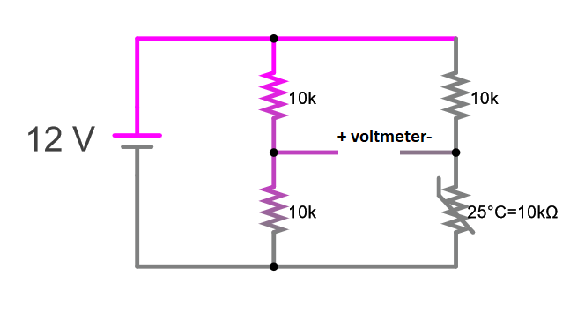
20. A four bit binary weighted resistor DAC has reference voltage of 5 V. Calculate step size, resolution, % resolution and full scale output if the minimum value of weighted resistor is 1kΩ and R_{f} = 1kΩ.

21. A dual slope digital voltmeter has an integrator of resistance 100 kΩ and capacitance 1 µF. If the input d.c. voltage is 2 V , what would be the output of the integrator after 1 Second? If a reverse voltage reduces the output to zero in 0.2 seconds, what is the value of the reverse voltage?

22. In a capacitance meter, an astable multivibrator using ic555 is used before the frequency counter. R_{A} = 2.2 kΩ, R_{B} = 5.6 kΩ and the counter counts 180 during discharge of capacitor (OFF time). The frequency of the clock gate pulse is 100 KHz. Calculate the value of unknown capacitance.

23. A 4 ¹/₂ digit voltmeter is used for voltage measurements:
(i) Calculate its resolution at 1 V FSD
(ii) How would 6.78 V be displayed in 10 V range?
(iii) How would 0.7526 V be displayed on 1 V range and 100 V range?

24. In the instrumentation amplifier circuit given below, R = 10 K, R_{GAIN} = 5.6 K. Calculate the output voltage if V₁ = 2 V and V₂ = 1.6 V, V_{CC} =12 V, V_{EE} = -12 V for all op-amps.
.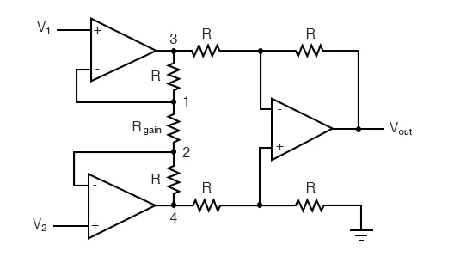

xxxxxxxxxxxxxxxxxxxxxxx

