

**ST JOSEPH’S UNIVERSITY, BENGALURU-27**

**M.Sc. ENVIRONMENTAL SCIENCE AND SUSTAINABILITY - II SEMESTER**

**SEMESTER EXAMINATION: APRIL 2023**

(Examination conducted in May 2023)

**ES 8522: ENVIRONMENTAL ECONOMICS**

(For current batch students only)

**Time - 2 Hours Max Marks - 50**

**This question paper contains two printed pages and three parts**

**Part A**

**Answer any five of the following 2m X 5q = 10m**

1. What is the normative approach in economics?
2. Define marginal cost.
3. What is market failure?
4. Give the meaning of WTA.
5. What are subsidies?
6. What are performance bonds?
7. Who is a free rider in environmental economics?

**Part B**

**Answer any four of the following 5m X 4q = 20m**

1. How does economics help in the study of environmental science?
2. Explain the types of goods with the help of a matrix.
3. Write a short note on Cost-benefit analysis.
4. Explain the function of the market mechanism.
5. What is Hardin’s tragedy of commons?
6. How do tradable permits work?

**Part C**

**Answer the following 10m X 2q = 20m**

1. a. Explain positive market externality. With the help of a diagram show how subsidies can be used to correct market externalities.

**OR**

b. Label the diagram given below to identify negative externality and shade the area of dead weight loss. What happens when a negative externality is taxed? Illustrate the outcome.

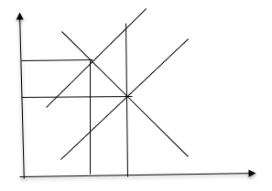

1. a. What is environmental valuation? Explain the Total Economic Value (TEV) framework of environmental valuation.

**OR**

b. Discuss the regulatory instruments used for environmental protection? How do they work to reduce pollution and promote sustainable practices?