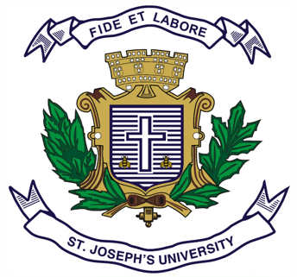
Registration Number:
Date & session:
Registration Number:
Date & session:

ST.JOSEPH’S UNIVERSITY, BENGALURU -27
B.A. INDUSTRIAL RELATIONS– II SEMESTER
SEMESTER EXAMINATION: APRIL 2023
(Examination conducted in May 2023)
IR 2121: HUMAN RESOURCE MANAGEMENT

(For current batch students only)

Time: 2 Hours Max Marks: 60
This paper contains TWO printed pages and THREE parts

PART-A
Answer any TEN of the following: (10x2=20 Marks)

- Define Human Resource Management.
- What is the meaning of Human Resource Planning?
- What comes first-Selection or Recruitment?
- What is Human Resource Audit?
- What is the meaning of Learning?
- Define Performance Appraisal.
- What is upskilling?
- What is Transfer?
- What is Work-Life Balance?
- What is the meaning of Development in connection with HRM?
- What is Promotion?
- Name any two resources which are necessary for any organization.

PART-B
Answer any FIVE of the following: (5x5=25 Marks)
- Write short notes on Human Resource Audit.
- Write short notes on Demotion.
- Give details of ‘Skilling’ and ‘Reskilling’.
- What is the Nature of Human Resource Management?
- Give your views on Work-Life Balance with reference to work from home.
- What according to you were the challenges faced by H.R. Managers during Covid-19 Pandemic and lock-down?
- What are the advantages and disadvantages of Performance Appraisal?

PART-C
Answer any ONE of the following: (1x15=15)
- Write an essay on any one type of Performance Appraisal OR Write an essay on various functions of H.R. Department with special reference to India.
- Write an essay on Recruitment OR Selection.

