ST. JOSEPH’S COLLEGE (AUTONOMOUS), BANGALORE – 27
II B.A– END SEMESTER EXAMINATION
MAY-JUNE 2023
WRITING AND THE ETHICAL PRACTICE OF JOURNALISM – JNI 422

Time- 2 hrs Max. Marks - 60

Instructions:

- This paper is for the students of IV semester JIN/JPP.
- This paper has FOUR parts and THREE pages.
- Answer the questions as instructed and mention word counts.
- You may use a dictionary.
Part A

I. Read the following excerpt by Arundhati Roy from her Frontline article titled “The Greater Common Good”:

Instinct led me to set aside Joyce and Nabokov, to postpone reading Don DeLillo's big book and substitute it with reports on drainage and irrigation, with journals and books and documentary films about dams and why they're built and what they do. My first tentative questions revealed that few people know what is really going on in the Narmada Valley. Those who know, know a lot. Most know nothing at all. And yet, almost everyone has a passionate opinion. Nobody's neutral. I realised very quickly that I was straying into mined territory. In the fifty years since Independence, after Nehru's famous "Dams are the Temples of Modern India" speech (one that he grew to regret in his own lifetime), his footsoldiers threw themselves into the business of building dams with unnatural fervour. Dam-building grew to be equated with Nation-building. Their enthusiasm alone should have been reason enough to make one suspicious. Not only did they build new dams and new irrigation systems, they took control of small, traditional systems that had been managed by village communities for thousands of years, and allowed them to atrophy. To compensate the loss, the Government built more and more dams. Big ones, little ones, tall ones, short ones. The result of its exertions is that India now boasts of being the world's third largest dam builder. According to the Central Water Commission, we have three thousand six hundred dams that qualify as Big Dams, three thousand three hundred of them built after Independence. One thousand more are under construction. Yet one-fifth of our population - 200 million people - does not have safe drinking water and two-thirds - 600 million - lack basic sanitation.

In India over the last ten years the fight against the Sardar Sarovar Dam has come to represent far more than the fight for one river. This has been its strength as well as its weakness. Some years ago, it became a debate that captured the popular imagination. That's what raised the stakes and changed the complexion of the battle. From being a fight over the fate of a river valley it began to raise doubts about an entire political system. What is at issue now is the very nature of our democracy. Who owns this land? Who owns its rivers? Its forests? Its fish? These are huge questions. They are being taken hugely seriously by the State. They are being answered in one voice by every institution at its command - the army, the police, the bureaucracy, the courts. And not just answered, but answered unambiguously, in bitter, brutal ways. For the people of the valley, the fact that the stakes were raised to this degree has meant that their most effective weapon - specific facts about specific issues in this specific valley - has been blunted by the debate on the big issues. The basic premise of the argument has been inflated until it has burst into bits that have, over time, bobbed away. Occasionally a disconnected piece of the puzzle floats by - an emotionally charged account of the Government's callous treatment of displaced people; an outburst at how the Narmada Bachao Andolan (NBA), 'a handful of activists', is holding the nation to ransom; a legal correspondent reporting on the progress of the NBA's writ petition in the Supreme Court.

I.A. Answer any TWO questions in 100-150 words each. (2x10=20)

- “My first tentative questions revealed that few people know what is really going on in the Narmada Valley”- If you were an editor working on this piece, what can you do for the readers at this point in the piece, in terms of getting Roy to amplify the concern in the piece?

- “Those who know, know a lot.” Do you think this sentence is enough from a reader’s point of view? Could this have been improved in some way in the editorial process?

- “From being a fight over the fate of a river valley it began to raise doubts about an entire political system. What is at issue now is the very nature of our democracy.” As a reader, do you think the idea of the article is clearly conveyed here? If yes, why would you say that? If not, what changes can be brought here?

Part B

II. Answer the following questions in 100-150 words each. (2x10= 20)

- “I was flattered by his desire to own the painting, but I didn’t feel the same urge to own the piece as he did. It seemed strange to me that he or I should have to buy back a picture of myself — especially one I had posted on Instagram, which up until then had felt like the only place where I could control how I present myself to the world, a shrine to my autonomy. If I wanted to see that picture every day, I could just look at my own grid.” What idea of ownership is Emily Ratajkowski presenting in these lines, taken from the longform piece “Buying Myself Back”?

- “We have a legal system and society that thrives on impunity”. Do you see the same reflected in the Tukaram vs State of Maharashtra (Mathura case)? If so, how? Connect it to other cases of judicial injustice in the country that you are aware of.

Part C

III. Draft an Instagram response for the cartoon given below in 100-150 words. (10 marks)

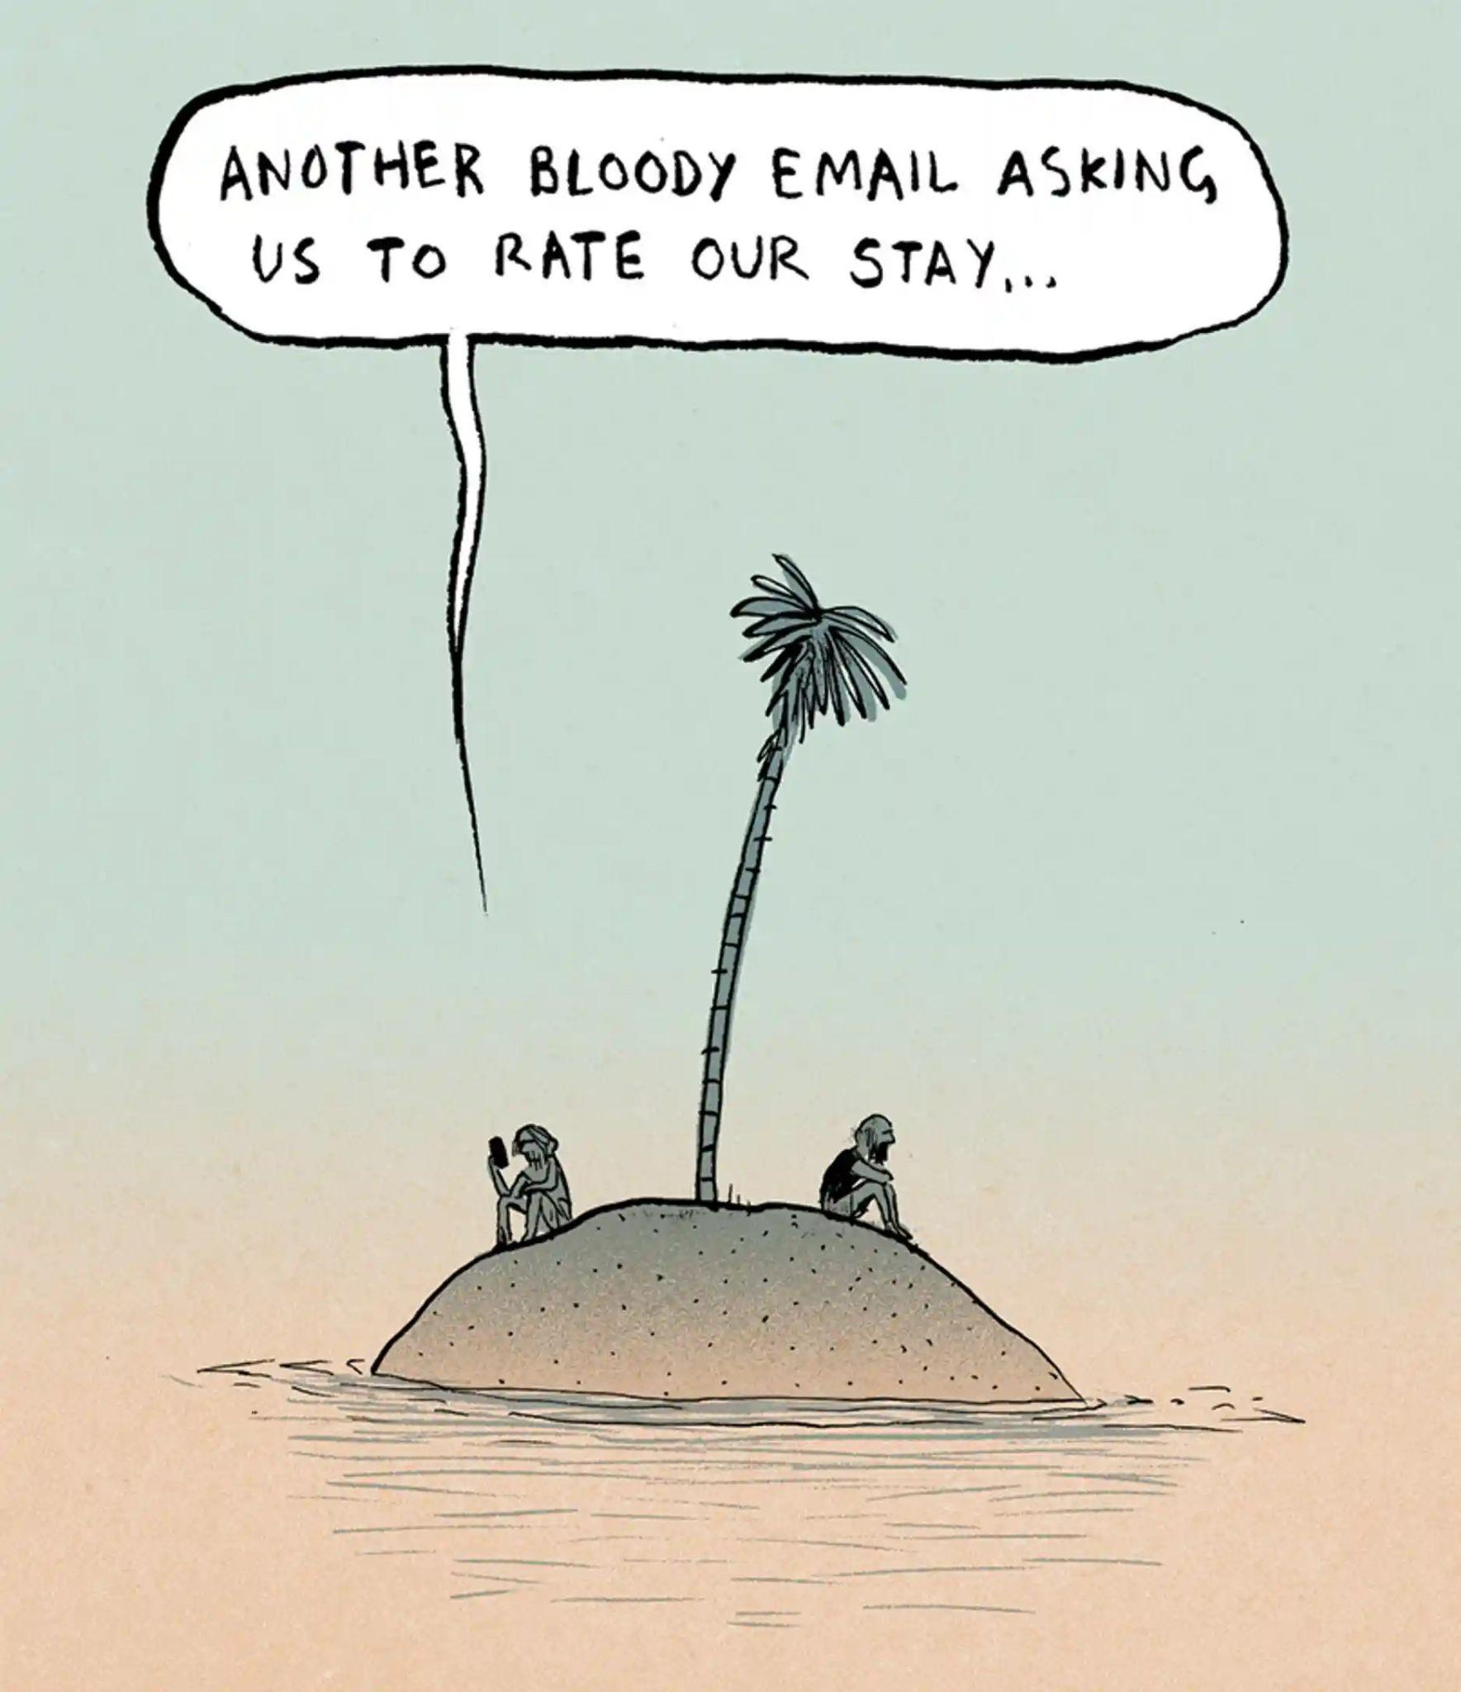
cartoon credit- Berger and Wyse, The Guardian

Part D

IV. Answer the following current affairs concerns in ONE paragraph each. (2x5=10)

- Rahul Gandhi’s disqualification from the Parliament.
- Amul vs. Nandini controversy in Karnataka.

*****

