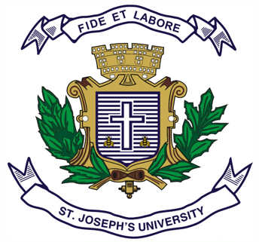
Register Number:
DATE:
ST. JOSEPH’S UNIVERSITY, BANGALORE-27
M.Com – II SEMESTER
SEMESTER EXAMINATION: APRIL 2023
(Examination conducted in MAY 2023)

MCO8520: DIGITAL MARKETING

(For current batch students only)

Time- 2 hrs Max Marks-50
This paper contains ONE printed page and three parts
Part- A
I. Answer any TWO of the following questions. 2x5=10
- Write short notes on payment gateways and UPI with suitable examples.
- Differentiate between SEO and SEM.
- Briefly explain Cookies and Google slap.

Part-B
II. Answer any TWO of the following questions. 2x15=30
- Discuss the benefits of the following:
  - Forums and discussion boards. (5m)
  - Viral marketing. (5m)
  - Affiliate marketing. (5m)
- a) Briefly explain the online pricing models. (5m)
b) What is YouTube marketing? Briefly explain its role in digital marketing. (10m)
- Explain the various tools for social media management.

Part- C
III. Answer the following question: 10x1=10
- a) Highlight and briefly explain the media options available for marketers with suitable examples.(5m)
b) If you were the owner of a restaurant, which media option would you choose and why? (5m)
**************

