Reg No:
Date:

ST. JOSEPH’S COLLEGE (AUTONOMOUS), BENGALURU - 27
OPTIONAL ENGLISH ELECTIVE – VI SEMESTER
SEMESTER EXAMINATION: MAY 2023
(Examination conducted in May 2023)
OE 6222 – GENRES IN POPULAR LITERATURE-II

(For current batch students only)

Time: 2 ½ Hours Max Marks: 70
This paper contains THREE printed pages and SEVEN questions.

INSTRUCTIONS:
- This elective is for students of EJP (Semester VI).
- You may refer to the excerpts provided but do not copy from them directly.
- You are permitted to use a dictionary during this examination.

I. Answer ANY TWO of the following questions in 120-150 words each. (2x10= 20 Marks)

- Mario Saraceni, in The Language of Comics, notes, “[With] drawn words,… the resulting image is neither purely verbal nor purely visual, but a blend of the two, and the meaning is based on both aspects.” While most studies of comic strips tend to focus on their visual elements, what are the different ways in which comic books/strips incorporate written text in specific manners? How can such graphic texts add layers of texture and meaning? Elaborate using examples you have encountered this semester.

- How does Calvin and Hobbes provide a continuous commentary on suburban United States in the late 20th century? Provide examples based on the comic strips you read in class to support your answer.

- Critically analyse the following comic strip taken from Matt Melvin’s Cyanide and Happiness. Why do you think the writer has included an unintelligible series of jumbled letters and numbers in the text? What does the text and style of illustration suggest about the medium of circulation of the comic?

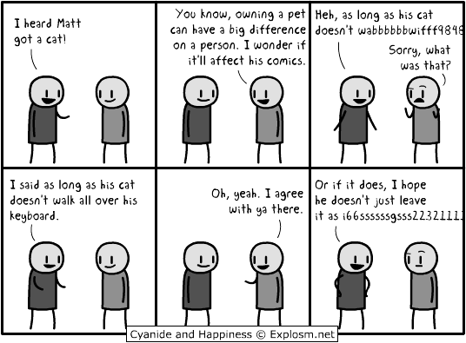

II. Read the following passage taken from The Palgrave Handbook of Utopian and Dystopian Literatures and answer the questions that follow.

The first major upsurge of dystopian literature occurred thereafter as a consequence of the immense popularity of Edward Bellamy’s Looking Backward 2000–1887 (1888). Bellamy’s modernist vision of the future portrayed a highly regulated, technologically centered, and largely urban society. Here all are educated to age 21, then serve for twenty-four years in the labor army. Some variation in employment is possible, but evasion of this duty is not, and those who shirk their responsibilities face being “sentenced to solitary confinement on bread and water” (Bellamy 2009, 75). (In the second edition this was rephrased to “cut off from all human society.”)… Another leading theme, which develops quite independently in this period, is anxiety about the role increasingly played by machinery in human society and its potential to overwhelm its creators.

- The above passage provides few of the central elements in early dystopian literature. How far has Veronica Roth’s Divergent replicated or diverged from these features? Explain briefly in about 150 words. (10 marks)

- Setting and atmosphere play a significant role in dystopian fiction. What tone and mood does dystopian fiction create? Pick a dystopian book or film with a memorable tone and attempt a critical analysis of the same (in 200-250 words). (15 marks)

III. Read the following excerpt taken from Joyce Carol Oates’ article “The Madness of Art” and answer the questions that follow.
Speaking as a writer predisposed to reading and frequently to writing what I call “Gothic” work, I should say that this so-called genre fascinates me because it is so powerful a vehicle of truth-telling, and because there is no wilder region for the exercise of the pure imagination. The surreal is as integral a part of our lives as the “real,” although one might argue that, since the unconscious underlies consciousness, and we are continuously bombarded by images, moods, and memories from that uncharitable terrain, it is in fact more primary than the “real.” The Gothic work resembles the tragic in that it is willing to confront mankind’s—and nature’s—darkest secrets…
Of course, horror fiction has its weaknesses. But so does “serious, literary” fiction. If there is any problem with the Gothic as an art, it is likely to lie in the quality of execution. In the literature of horror, a handicap has frequently been that of verisimilitude, the relative weakness or flatness of character. H. P. Lovecraft spoke of the “weird” rather than the Gothic, which seems to me, for all my admiration of Lovecraft’s masterly work, unnecessarily restricting. To Lovecraft, too, “phenomena” rather than “persons” are the logical heroes of stories, one consequence of which is two-dimensional, stereotypical characters about whom it is difficult to care. Situations and plots may be formulaic, language merely serviceable, and not a vehicle for the impassioned inwardness of which “weirdness” is one attempt at definition, but only one. The standards for horror fiction should be no less than those for “serious, literary” fiction in which originality of concept, depth of characters, and attentiveness to language are vitally important.
Gothic fiction is the freedom of the imagination, the triumph of the unconscious. Its radical premise is that, out of utterly plausible and psychologically realistic situations, profound and intransigent truths will emerge. And it is entertaining; it is unashamed to be entertaining.
- H. P. Lovecraft comments on how “phenomena” rather than “persons” are the foundational elements of a horror story. What do you understand from this statement? Do you agree with this remark? Explain, in around 150 words, using examples from the texts you read this semester. (10 marks)

- Oates emphasizes how horror literature is “unashamed to be entertaining”. Does this make horror fiction different from other genres? Do horror literature entertain readers/viewers in the same manner as horror films? Comment on the above (in 200-250 words) basing your observations on any texts you have encountered. (15 marks)

