Registration Number:
Date & Session:
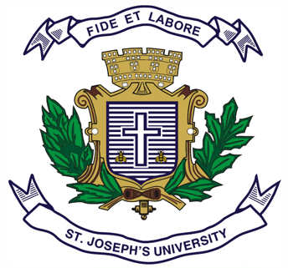

ST. JOSEPH’S UNIVERSITY, BENGALURU-27
M.A. (POLITICAL SCIENCE) – II SEMESTER
SEMESTER EXAMINATION: APRIL 2023
(Exam conducted in May 2023)
PS 8222: DEVELOPMENT ADMINISTRATION: THEORIES AND CONCEPTS
(For current batch students only)

Time: 2 Hours Max Marks-50

This question paper contains 1 printed page and two parts

PART-A
Answer any FOUR out of the following SIX questions in 60-80 words each (4X5= 20 Marks)
1. Explain the Socialist and Third World Models of Development.
2. Explain Leibenstein’s Critical Minimum Effort Thesis.
3. Write on the concept of Post- development Model.
4. Write a note on Decentralization and Development.
5. Explain the importance of Citizens participation in the process of Development.
6. What is Centralized Planning System? Give an example of the same.

PART-B
Answer any THREE out of the following FIVE questions in 300-`400 words each (3X10= 30 Marks)

7. How was the discipline of Development Administration different from that of traditional administration? Explain citing the distinctive features of the former.
8 Explain W.W. Rostow’s Five stages of Economic Growth & Development.
9. Critically examine any five SDGs.
10. Examine the role of Foreign Aid in Development Administration citing the examples of the World Bank and the Asian Development Bank.
11. Write short notes on: (In about 200 words each)
a. Role of ADB in poverty eradication
b. Economic and Social exclusion

PS 8222-A-2023

