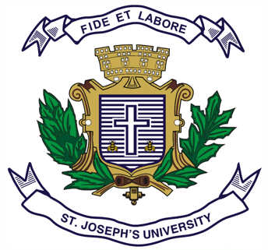
ST. JOSEPH’S UNIVERSITY, BENGALURU -27
Registration Number:
Date & Session:
M.A (POLITICAL SCIENCE) – IV SEMESTER
SEMESTER EXAMINATION: APRIL 2023
(Examination conducted in May 2023)
PS 0122: MODERN POLITICAL THOUGHT

Time: 2 ½ Hours Max Marks: 70
This paper contains ONE printed page and TWO parts

PART-A

Answer any FOUR of the following SEVEN questions in 60-80 words each (4x5=20)

- Explain the concept of base and superstructure in Marxism.
- Describe the features of the General Will as provided by Rousseau.
- What is Cultural Hegemony?
- Discuss T.H. Green’s conception of idealism.
- Analyze the idea of the ‘Spirit’ in Hegelian philosophy.
- What is the State of Nature in Social Contract Theory?
- Write about Mao Zedong’s Great Leap Forward.

PART-B

Answer any FIVE of the following SEVEN questions in 120-150 words each (5x10=50 Marks)

- Analyze how Mill’s conception of utilitarianism was different from his predecessor Jeremy Bentham.
- What is Dialectical Idealism? Explain the relevance of Dialectics in Hegel’s Theory of the State.
- How does Amartya Sen in his work discusses the different aspects of Identity.
- Explain Historical Materialism as provided by Karl Marx.
- Highlight Locke’s philosophy of Individual rights and freedom as discussed in the Two Treatise.
- Describe Hannah Arendt’s understanding of ‘The Human Condition’.
- What has been Lenin’s contribution to Marxism? Discuss briefly his Theory of Imperialism.

PS 0122_A_23

