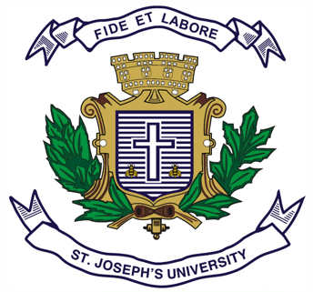
ST. JOSEPH’S UNIVERSITY, BENGALURU -27
Registration Number:
Date & Session:
M.A (POLITICAL SCIENCE) – IV SEMESTER
SEMESTER EXAMINATION: APRIL 2023
(Examination conducted in May 2023)
PS 0222: INTERNATIONAL ORGANIZATIONS
Time: 2 ½ Hours Max Marks: 70
This paper contains ONE printed page and TWO parts

PART-A

Answer any FOUR of the following SEVEN questions in 60-80 words each (4x5=20)

- What do you understand by the concept of Global Governance? Discuss some of its prospects and challenges.
- Write a note on UN reforms as suggested by UN Secretary General Kofi Annan.
- Discuss the main points of contention between India and the Non-Proliferation Treaty.
- Explore the nature and scope of International Law.
- Write a note on G-8.
- Summarize the relevance of IBSA for India.
- Analyze the features of International Human Rights Law.

PART-B

Answer any FIVE of the following SEVEN questions in 120-150 words each (5x10=50 Marks)

- Examine the historical evolution and features of the UN Charter. In this light, describe the peacekeeping and peacebuilding efforts of UN in the post-cold war era.
- Discuss the significance of BRICS in manifesting the idea of multilateralism in international politics.
- What is an International Organization? How did International Organizations become an important aspect of IR through the process of history?
- Analyze the Realist and the Liberal perspective of International Organizations.
- Explain how the IMF and World Bank showcase the dominance of the developed states in the world economy?
- Highlight the key aspects of India’s relationship and transition with regards to the UN.
- Explain the role of NATO and its expansion in the context of international security in world politics.

PS 0222_A_23

