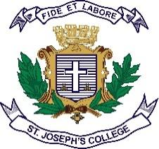
Date:
Registration number:
ST.JOSEPH’S UNIVERSITY, BENGALURU -27
M.Sc (ZOOLOGY) – II SEMESTER
SEMESTER EXAMINATION: APRIL 2023
(Examination conducted in May 2023)
ZO 8522 – ENTOMOLOGY
(For current batch students only)

Time- 2 ½ hrs Max Marks-50

This question paper contains 2 printed pages and four parts

Part A
Answer all the questions : 5x 1= 5
1. Photoreceptor
2. Halteres
3. Fumigants
4. What are organochlorines?
5. Name two oligophagous pests

Part B
Answer all 5 of the questions : 5 x 2 = 10
6. Paedogenesis
7. GMR
8. Role of insects in Forensic entomology
9. Give 4 characters of class Insecta
10. Entomophagous nematodes

Part C
Answer ANY of the 3 questions : 3 x 5= 15

11. What is the role of pheromones in insect management?
12. Japanese encephalitis
13. Explain the hormonal control of insect metamorphosis.
14. Discuss the success of biological control in agriculture
15. How do VOC’s play a role in insect plant interactions?

Part D

Answer any two questions: 2 x 10= 20

16. a) With a diagram, depict the female reproductive systems in insects (5m)
b) What are organochlorines and carbamates (5m)
17. What is Integrated pest management? Emphasise the aims and write a note on
the advantages and challenges farmers face with IPM.
18. a. Give the biology and management of any two pests of stored products.
b. What are economically important insects? Explain any one.
*********

