ST.JOSEPH’S UNIVERSITY, BENGALURU -27
Registration Number:
Date & session:
B.Sc. (ZOOLOGY) – II SEMESTER
SEMESTER EXAMINATION: APRIL 2022
(Examination conducted in May 2023)
ZO 221 – Biochemistry and Physiology
(For current batch student only)

Time: 2 Hours Max Marks: 60
This paper contains two printed pages and four parts
NOTE: Draw neat labeled diagram wherever necessary

PART-A

Answer the following: 5 X 1 = 5
- The modification of biomolecule by the addition of phosphate group is mediated with the help of ______ class of enzyme.
- Sucrose, consist of a molecule of glucose and a molecule of fructose, they are linked together by ________ linkage.
- What does native confirmation of protein mean?
- Define Cardiac output.
- Name the instrument in the image-

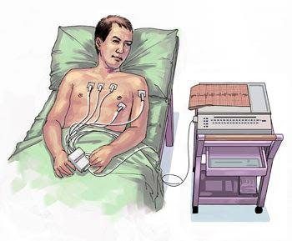

PART-B
Answer the following: 5 X 2 = 10
- Define Ketogenesis.
- Draw the structure of Amylopectin.
- List any four differences between smooth and skeletal muscles.
- Identify the hormonal disorder in the image given below and mention its causes.
- Draw and label the parts of stomach.
PART-C
Answer any THREE of the flowing: 3 X 5 = 15
- Add a note on the different levels of organization of proteins.
- Mention the biological importance of the following
Vitamin A, Vitamin B12, Vitamin C, Vitamin D, Vitamin K
- Explain cardiac cycle and cardiac output.
- Draw and label the structure of a nephron. Add a note on JGA.

PART-D

Answer any THREE of the following questions 3 X 10 = 30

- Schematically represent Pentose Phosphate Pathway.
- Give a brief account on the different classes of enzymes with a suitable example for each.
- Explain the antagonistic action of Calcitonin and PTH in calcium metabolism
- Explain the propagation of nerve impulse across the nerve fiber

