Registration Number:
Date & Session
ST. JOSEPH’S COLLEGE (AUTONOMOUS), BENGALURU -27
B.Sc. ZOOLOGY - IV SEMESTER
SEMESTER EXAMINATION: APRIL 2023
(Examination conducted in May 2023)
ZO 422- IMMUNOLOGY, GENE TECHNOLOGY AND HISTOLOGY
(For current batch student only)

Time - 2 hrs |  |  | Max Marks - 60
This paper contains 2 printed page and three parts
Note: Draw neat labelled diagrams wherever necessary

PART A
Answer the following: 10 X 1 = 10

- Which hormone is responsible for erythropoiesis?
- Dr. V was scanning a histological section of the tongue, he spotted one variant of papilla, which didn’t bear taste buds, which type of papilla did Dr. V spot under the microscope?
- Circumvallate
- Foliate
- Filiform
- Fungiform
- List out any three properties of cytokines.
- The antrum of the ovarian follicle is filled with _________fluid.
- What causes autoimmune anaemia?
- The phage genome modifies itself from linear genome to circular genome by connecting the _____ site.
- Differentiate between Mast cells and Dendritic cells.
- Mention any one product developed using genetic engineering in the following area,
- In the agricultural sector -
- In the vaccine sector -
- Which among the thyroid follicles given below is highly active?
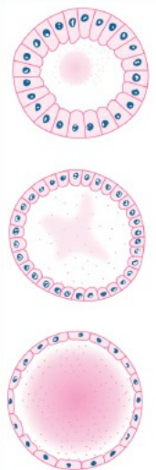

A B C

- Define “immunological memory”

PART B
Answer any FOUR of the following: 4 X 5 = 20

- Write a short note on antigen presenting style of MHC class I & class II molecules.
- Describe the histological makeup of adrenal gland. Add a note on its secretions
- Explain the structure of an antibody with a neat labelled diagram.
- With neat labelled diagram discuss the different components of PBR322.
- Explain the histological organization of Spleen.
- What is hypersensitivity? Explain the major immunologic reactions for its types.

PART C
Answer any THREE of the following: 3 X 10 = 30

- Explain the immunologic basis of graft rejection.
- Describe the histological details of mammalian kidney
- Give a general account on Adjuvants, immunologic tolerance and immunosuppression.
- With neat illustration describe electroporation and liposome mediated gene transfer.

