Register Number:
DATE:
ST. JOSEPH’S COLLEGE, BANGALORE-27
BBA/BBASF – V SEMESTER
SEMESTER EXAMINATION: OCTOBER 2023
(Examination conducted in November/December 2023)
BADEI 5523 : FOREX MANAGEMENT
(For Current batch students only)

Time- 2 hrs Max Marks-60

This paper contains _____ printed pages and four parts
Section A
I. Answer any five of the following (5x2 = 10 Marks)
- What is Forex Management?
- Give the meaning of Electronic Trading.
- State the importance of Currency Derivatives.
- What do you mean by Treasury Management?
- Mention the internal techniques used for managing the Foreign Exchange Risk.
- What is Hedging?

Section B
II. Answer any four of the following (4x5 = 20 Marks)
- Bring out the difference between FEMA and FERA.
- Summarise on the types of Currency Derivatives.
- From the Chart below write an interpretation of the currency movements USD/INR

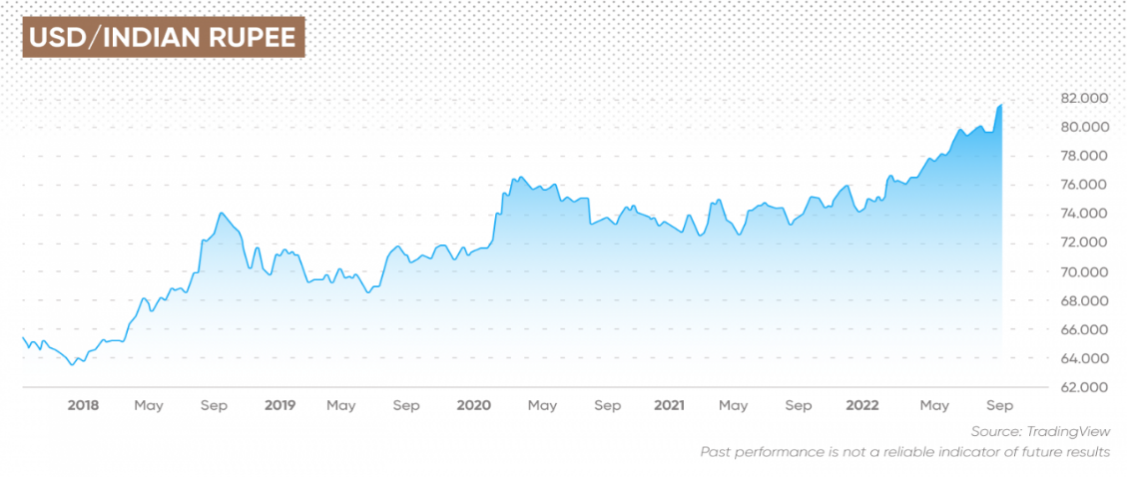
- How do you manage foreign exchange risk for a business?
- Write a short note on Organisation structure of a Treasury Management Department.
Section C
III. Answer any two of the following (2x10 = 20 Marks)
- Explain the advantages and disadvantages of Currency derivatives.
- Discuss in detail the types of Foreign Exchange Risks.
- Write a brief note on the functions of the Treasury Management Department.

Section D
IV. Answer the following (1x10=10 Marks)
- Give a note on the following concepts in Forex Management:
(a) Cash forecasting
(b) Investment management

