Register Number:
DATE:
ST. JOSEPH’S COLLEGE (AUTONOMOUS), BANGALORE-27
BCOM –V SEMESTER
SEMESTER EXAMINATION: OCTOBER 2023
(Examination conducted in November/December 2023)

BCDEM5523: Retail Management

Time- 2 hrs Max Marks-60

This paper contains TWO printed pages and FOUR parts

Section A
I. Answer any five of the following (3 x 5 = 15 marks)
- Differentiate between organised and unorganised retailing.
- Describe the Theory of Natural Selection.
- Enlist three types of store layout.
- State three advantages and three disadvantages of E-Retailing.
- What are the different social issues faced by retail business?
- State any six drivers of change in retailing.

Section B
II. Answer any two of the following (5 x 2 = 10 marks)

- Briefly explain the functions of retailing.
- Diagrammatically explain the BCG matrix with relevant example.
- Explain the methods of waste reduction in a retail store.

Section C
III. Answer any two of the following (10 x 2 = 20 marks)
- Write a short note on:
a) Retail Life Cycle Theory (5 Marks)
b) Ansoff Matrix (5 Marks)
- "Retailers who don't embrace technology will be left behind in the fast-paced digital marketplace." - Stephanie Dismore. Explain the various technology that has an impact on Retailing.
- A major global retail chain faced public backlash when it was revealed that their overseas suppliers employed child labor in unsafe working conditions, raising concerns about their commitment to ethical sourcing and labor practices. Explain are the various ethical and legal issues that retailers can face?

Section D
III. Answer the following (15marks)
- Huda Beauty: Cosmic experience in Covent Garden

In 2013 Huda joined forces with her two sisters, Mona and Alya to launch Huda Beauty, with its own range of tried and trusted high-end beauty and make-up products, leading to the global phenomenon the brand is today; one of the fastest growing beauty brands in the world.
Huda was inspired to create a unique pop-up experience for advocates of the Huda Beauty brand and ran an immersive retail experience pop-up store right in the centre of Covent Garden, London, to launch a new product range and reach new customers.

Huda used the location (sourced by Storefrontpop up space rental) to deliver a sci-fi themed experience in support of their new eye-shadow palette Mercury Retrograde.

The entire exterior of the pop-up resembled a multi-faceted, metallic mass of geometrical shapes. The Huda Beauty pop-up store was painted pink from top to bottom, and its walls are covered in angled mirrors; offering customers a unique outer-space inspired experience. This was echoed inside with various ‘galactic’ elements, all manner of mirrored surfaces and shimmering fixtures and elements.

There is no doubt that the more engaging and immersive a physical experience is, the stronger and more long lasting the relationship with the brand will be. As Sophie Maisant, International Marketing VP for Huda Beauty elaborates: “The pop-up allowed customers to develop an emotional connection with all that Huda embodies in the brand and enabled them to enter her world and physically experience it.”

As part of the event, visitors could sit on the throne Huda used in her launch material, all set up to encourage as much social media activity and engagement as possible.
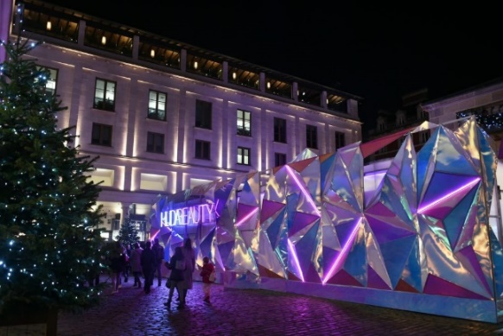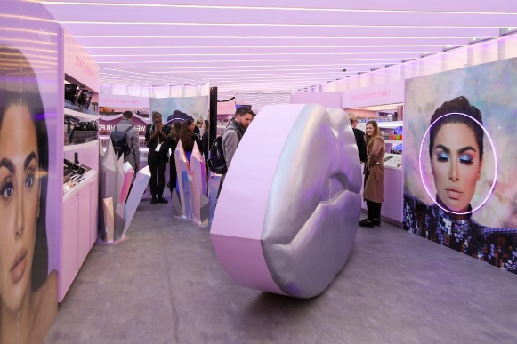
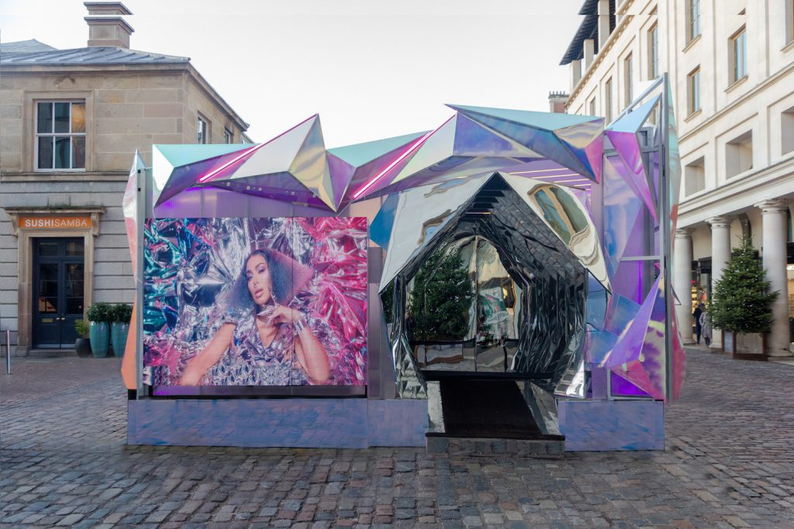

a) How was the store's interior and layout designed to create a cosmic and immersive atmosphere? (3 Marks)
b) How did Huda Beauty showcase its products through visual merchandising within the Cosmic Experience? (2 Marks)
c) Explain the various methods of building retail store image. (5 Marks)
d) Briefly explain the role of visual merchandising in retail stores. (5 Marks)

