ST. JOSEPH’S COLLEGE (AUTONOMOUS) BENGALURU-27
SEMESTER EXAMINATION- OCTOBER 2023
(Examination conducted in November/December-2023)
BPS: V SEMESTER
BPS5523: CAPITAL MARKETS FOR BPS
TIME: 2 Hours MAX. MARKS: 60 Marks
SECTION A
Answer any FIVE of the following questions. Each question carries two marks. (5x3=15)
- Give the meaning of marked to market.
- Differentiate between bonus issue and stock split.
- What is meant by limit order? Give an example.
- Name any three benefits of investing in Fixed Income Securities.
- List out any three types of issuing shares to the public.
- What is derivative? Give an example.

SECTION B
Answer any TWO of the following questions. Each question carries five marks. (2x5=10)
- What are bonds? Explain its types.
- Differentiate between Investment and Hedging.
- Explain the concept of swaps with an example.

SECTION C
Answer any TWO of the following questions. Each question carries fifteen marks. (2x10=20)

- Future market is a standardized market. Discuss the features of futures by differentiating from forwards.
- What is meant by Mutual Fund? Briefly summarise the classification of Mutual Fund schemes.
- Write a note on the following;
  - Position reconciliation
  - Corporate actions

SECTION D
Answer the following compulsory question. The question carries Fifteen marks. (1x15=15)

- EMS Limited incorporated in 2010, is a multi-disciplinary EPC (engineering, procurement & construction) company, headquartered in Delhi that specializes in providing turnkey services in water & wastewater collection, treatment and disposal. It consists of government contracts like sewerage solution provider, water supply system, water & waste treatment plants, electrical transmission & distribution, road & allied works, operation & maintenance of Wastewater Scheme Projects (WWSPs) and Water Supply Scheme Projects (WSSPs). It has a team of 61 engineers who are supported by third-party consultants and industry experts to ensure compliance and quality standards. The net proceeds of the fresh issue will be deployed towards funding working capital requirement up to ~₹101 cr in FY24 and the rest for general corporate purposes. The promoters of the company hold 97% stake in the company.
The company operates in the following segment:
- Sewage Treatment Plants & Sewage Schemes– It is to aid the collection of
the sewage or domestic wastewater from each household through pipelines, 10% and intermediate pumping stations, to take it to a common facility which is
called a Sewage Treatment Plant where this sewage water is treated up to
the current stringent norms or up to the standards to reuse this treated
water in horticulture, refrigeration and processing industries.
- Common Effluent Treatment Plants – They provide specialized tailor-made solutions for recycling and reuse of contaminated wastewater produced by different industries.
- Water Treatment Plants and Water Supply Schemes – This includes raw water pre-treatment, clarification, filtration and disinfection.
- Operations & Maintenance (O&M) – This involves bidding for most turnkey projects in the field of WWSPs and WSSPs which are being invited along with O&M for a period depends on the requirements of customers. O&M contracts generally include operations, maintenance and supply of consumables and spares providing continuous revenue.
Sector Outlook: India is the world’s 2nd most populated country with 1.4 billion people. Out of this, 65% of the population lives in rural area and 35% are connected to the urban centers according to United Nation (2019). The metropolitan cities of the country are seeing major expansion as a result of economic expansions and reforms which is unsustainable without efficient planning of cities and provision of utility services especially clean and affordable water. Water allocation in cities are usually done from common pool with multiple sectoral demand. It is expected that by 2050, about 1,450 cubic km of water will be required out of which ~75% will be used in agriculture, ~7% for drinking water, ~4% in industries, ~9% for energy generation. However, because of growing urbanization, the need for drinking water will take precedence from the rural water requirements.
According to the by Central Pollution Control Board (CPCB), the estimated wastewater generation was almost 39,600 million litres per day (MLD) in rural regions, while in urban regions it was estimated to be 72,368 MLD for CY21. The estimated volume in the urban cities is almost double than that of the rural regions because of the availability of more water for sanitation which has increased standard of the living. The Government of India (GoI) has come up with various schemes that emphasizes on water conservation and restoration. As a result, the number of polluted river stretches has reduced from 351 in 2018 to 311 in 2022 and improvement in water quality has been observed in 180 out of 351 Polluted River Stretches (PRS) during the year 2018. Some of the schemes by GoI for wastewater management are Jawaharlal Nehru National Urban Renewal Mission, Atal Mission for Rejuvenation and Urban Transformation, Namami Gange programme and Swachh Bharat Mission. In India, the sewage generation in the urban region was 72,368 MLD for CY21, while the installed sewage treatment capacity is 31,841 MLD. The operational capacity is on 26,869 MLD, which is very low than the load generation. Of the total sewage generation only 28% was treated which implies that 72% of the wastewater is left untreated and is disposed in the various water bodies like river, lakes or underground water.
The company is highly dependent on the government projects and changes in government policies related to the environment and water treatment. As 100% of the projects are works related to tenders floated by government or semi government agencies funded through World Bank. These projects are awarded through the competitive bidding process. They have been black-listed in past by the two government bodies. The reason for blacklisting was inadequacy of the safety equipment’s/measure provided to the laborers pointing towards inferior workmanship and leading to death of five laborers. Another reason was falsely & fraudulently mentioned certain wrong facts in Forms 2 and 3B of the Standard/ Model Bid Documents (SBD), submitted in response to an invitation for bid for the work in question.
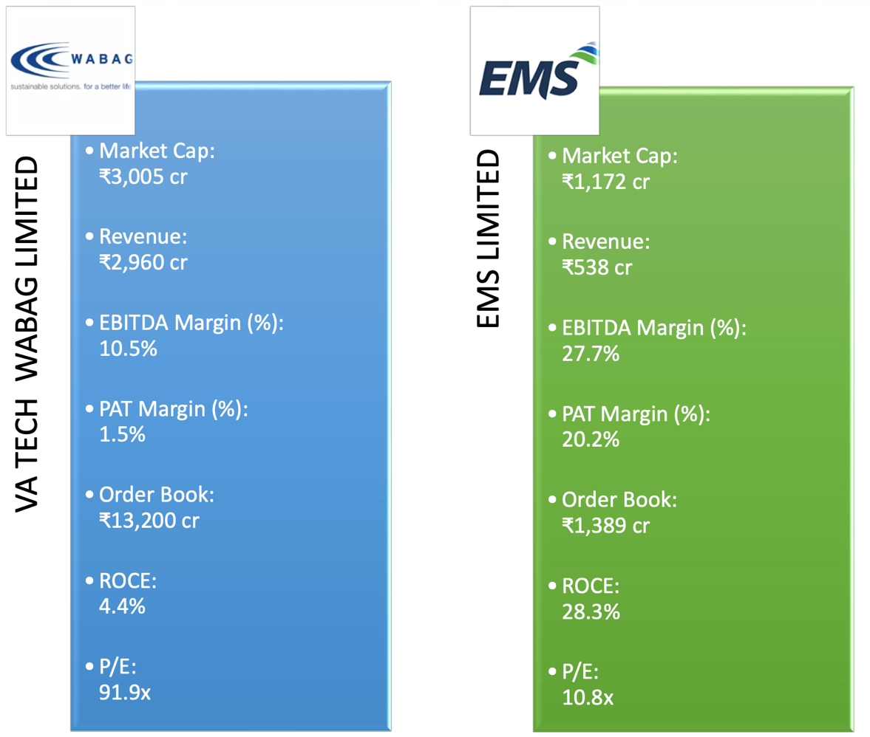
Competitive landscape: Comparison of financials among its peers

TITIVE LANE

Questions:

  - Prepare SWOC analysis of EMS Limited. (7 Marks)
  - Explain various players involved in the successful listing of shares of companies in the IPO’s. (8 Marks)

************ End of Question Paper *****************

